Scratch Assignment
Breakout!

For this assignment you are going to create a breakout pong game. You may refer to any breakout game from the Scratch network or other sites. The game must be created using Scratch.

Criteria:
- Sound: Sound must be present at sometime during the game. Sound must end when the games has ended.

- Counter: A counter must be present to keep score/time/lives and may be used to determine when levels are changed.

- Levels: A total of 3 game levels where each level changes in some way. I don’t want levels 2 and 3 to be duplicates of level 1. The background, speed, size of the pong ball, or paddle size should be changing from level to level.

- Breakout blocks: The breakout boxes must change position, size, color, number, etc from level to level

- Backgrounds: In addition to level backgrounds, you must have both a Winner and Loser background to indicate whether the player has won or lost. The game has to end in some way.

- Directions: Clear directions must be included in the project notes or as a sprite.

- Spelling and punctuation: Project and directions must be error free.

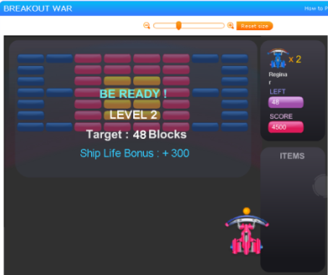
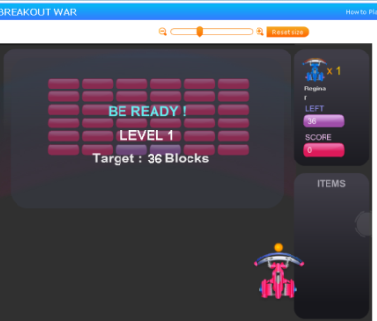

When you are done:
Upload your game to Scratch to the appropriate gallery and pass in the rubric.
Take a screen shot of the stage costumes, ie, levels, winner and loser screens.
Answer the questions from the electronic notebook and pass them in.

