Simple movement
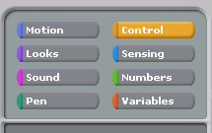
In Scratch the figure is called a Sprite. One of the easiest programs to make is one that moves a sprite on the screen.
- Click on the yellow Control button in the topic box
- A series of control instructions will appear
- Select the first one when flag is clicked and drag it to the Scripts area of the screen.
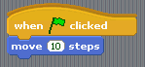
- Next click the blue Motion button to the left of the Control button to evoke the motions instruction set
- Drag the move 10 steps button across and lock it underneath the earlier command. Your program should look like the one on the right.
- Click the green flag near the top right of the Scratch screen to run your program.
Amending the program
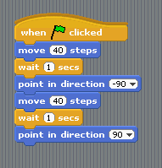
- You can change the amount of movement by altering the value in the movement command. Change the movement value from 10 to 40.
- Click the Control topic button again and select the wait 1 secs command
- Click the Motion topic button and add the point in direction 90 command below it.
- Click on the arrow beside the 90 and select -90 from the list.
- Add another movement command and change the value to match the first
- Add another wait command, and then another 'point' command.
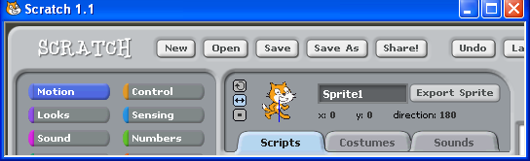
Finally, at the top of the screen where there is a small image of the sprite, click the middle button This makes the sprite change direction to match his movement.
Click this button so that the sprite faces the other direction when it changes direction
Repeated movement (using forever)
Often we want the sprite to be animated for a period of time. In order to get the script that we have written to loop use the Forever instruction.
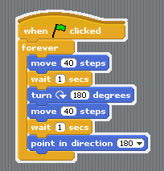
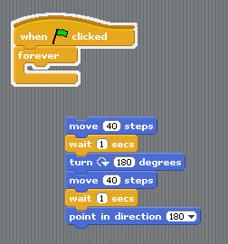
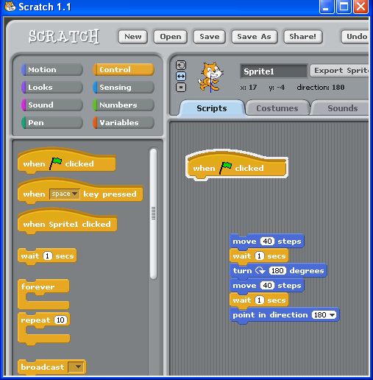
Step 1 - click the move 40 steps command and drag the script apart
Step 2 - Select the Forever instruction from the Control topics

Step 3 – Drag the set of instructions that you made previously back inside the forever instruction

Getting the sprite to walk (using costumes)
Click on the costumes tab – note that the cat sprite comes with two costumes
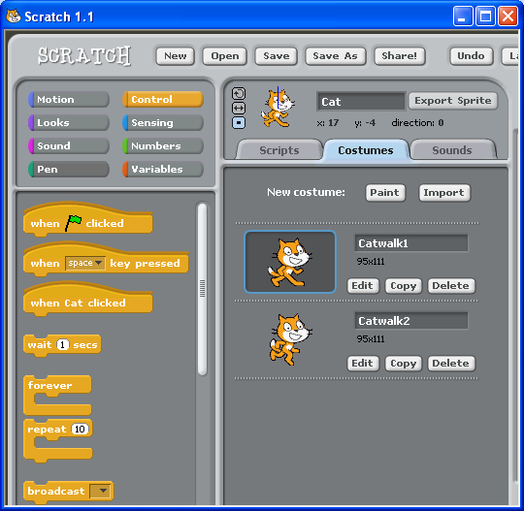
Rename the sprite as Cat

Rename the costumes Catwalk1 and Catwalk2

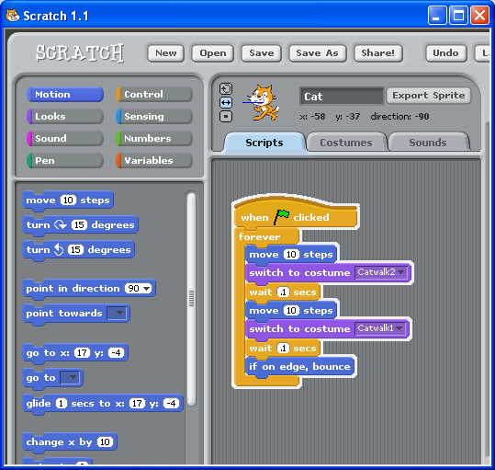
Before completing this exercise dump your existing script into the left had side of the screen (this will delete it)
Create a new script and drag in the move 10 steps instruction

Drag in the switch to costume and select Catwalk2 from the drop down list

Repeat the move, switch costume and wait steps to go back to Catwalk1

Drag in a wait and change the value from 1 sec to 0.1 secs

Add an if on edge, bounce instruction

Using the keyboard to control your sprite (using if condition instruction)
It is possible to control your sprite using the mouse keys. There is a small pointer next to the Sprite symbol at the top of the screen which can be set to any angle thereby determining the natural direction of movement of the sprite. In this exercise we want the Sprite to move exactly up and down vertically or side to side horizontally so we will use the change x by and change y by instructions to order to ensure the correct movement of the Sprite
Before completing this exercise dump your existing script into the left had side of the screen (this will delete it)
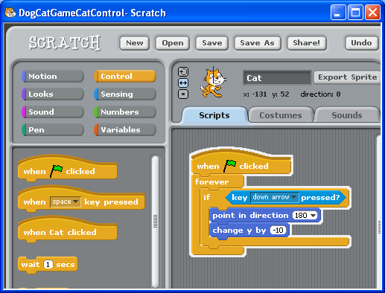
Choose the if condition instruction and drag in the key pressed instruction from the sensing topics. Set the key pressed to down arrow
Add the point in direction and change y by set instructions Set point in direction to 180 and change y by to -10
Start a new script with the when green flag pressed and forever instructions

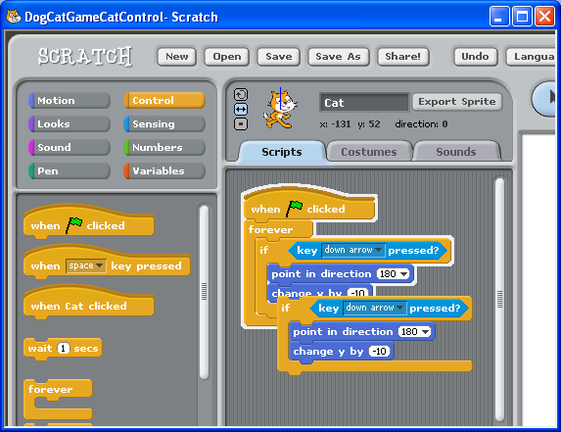
We will now copy the main part of the script then edit the sub script for each movement of the mouse determined by each of the respective four arrow keys
Click on the copy (stamp symbol) tool then click on the word if in the script. This will create a copy of that part of the script. Repeat this process twice more in order to create the scripts for each different movement of the sprite
Drop the three new copied sets of instructions inside the forever instruction (not inside the existing If condition instruction)

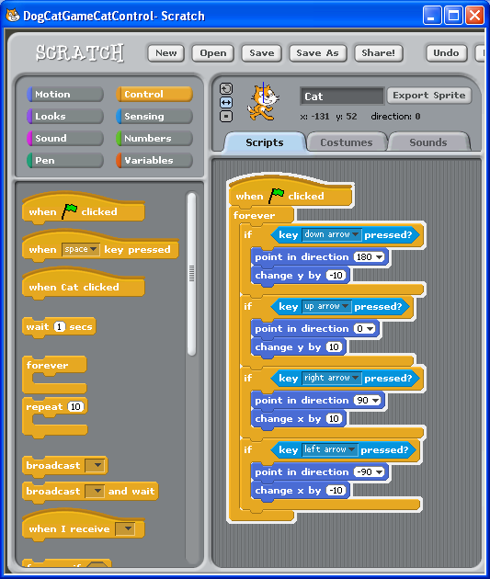
Set the key pressed to up arrow
Set the point in direction to 0
Set the change y by to 10
Set the key pressed to left arrow
Set the point in direction to -90
Set the change y by to -10

Set the key pressed to right arrow
Set the point in direction to 90
Set the change y by to 10

Click the green flag button.
It should now be possible to drive your cat sprite around the screen using the arrow keys
cat walking with keyboard control
Looking back over exercise 4 and 5 it should be possible to make a script combining what you have already learned that allows the Cat sprite to walk around the screen.

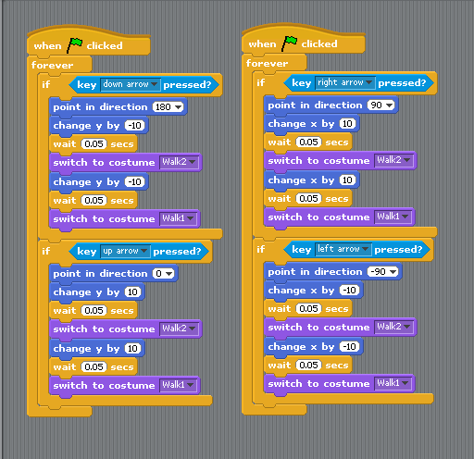

Note that two scripts have been created here as an expedience for display purposes and it is possible to combine all of this into one script

