DEBUG IT!
a collection of puzzling Scratch programs
BUG #1
Amos wants his cat to rotate when he presses the space bar. But the cat isn’t moving! What’s going on?

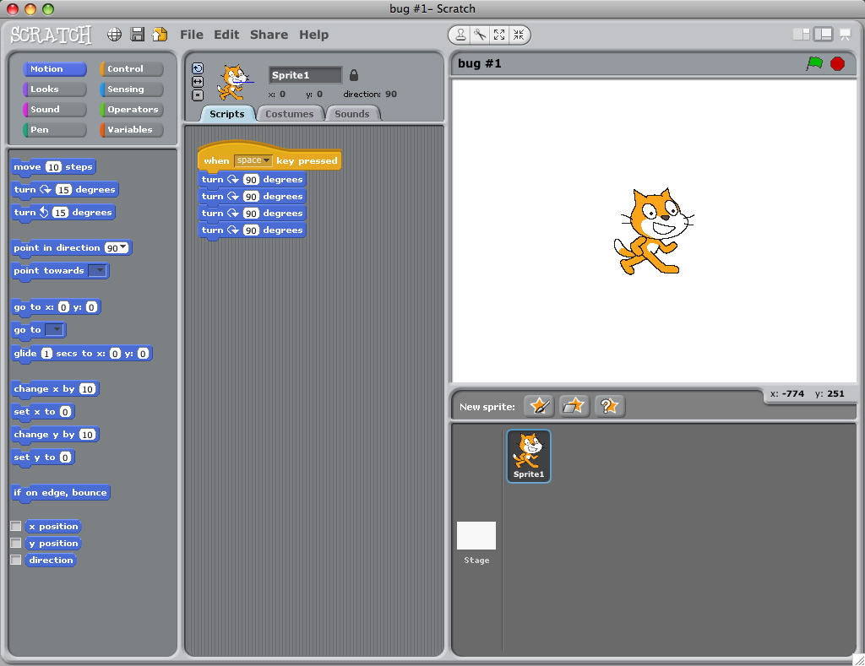
BUG #2
Stephanie wants the cat to start in the middle of the stage, then move across the stage and grow. It works the first time she clicks the green flag – but not when she clicks it again! What’s going on?

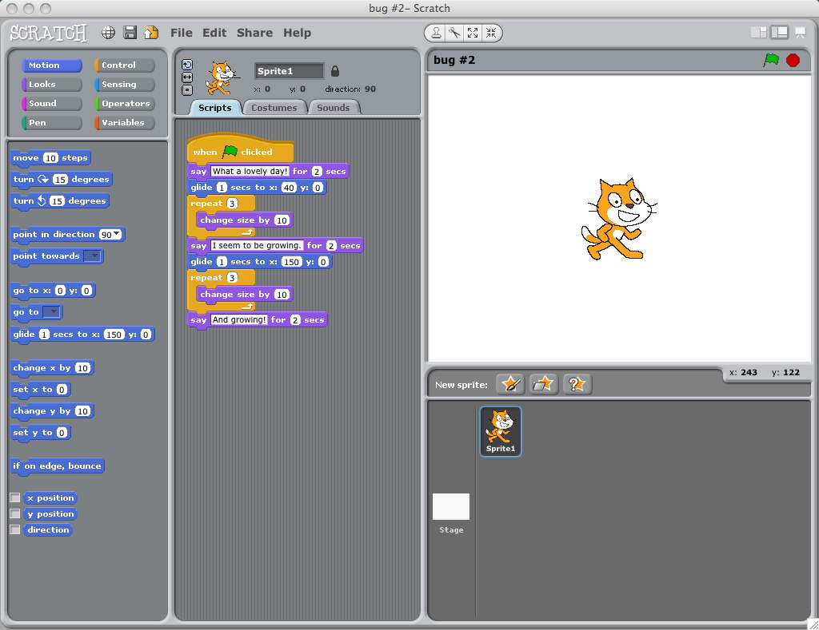
BUG #3
Mitch wants his cat to dance to some music. But the cat is dancing after the music is over! What’s going on?

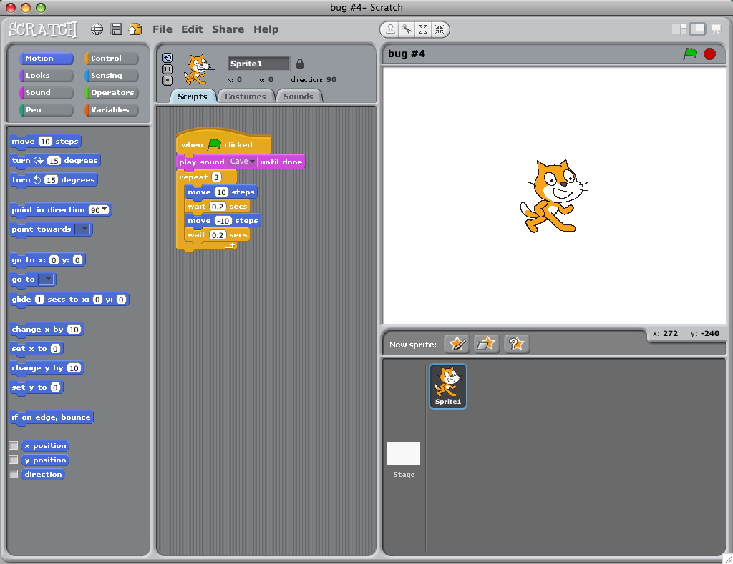
BUG #4
Karen wants to control the cat’s x-position with the keyboard: right arrow moves the cat right, left arrow moves the cat left. She also wants the cat to say if it’s on the right side or the left side depending on its x-position. The cat’s moving, but not saying its position correctly! What’s going on?

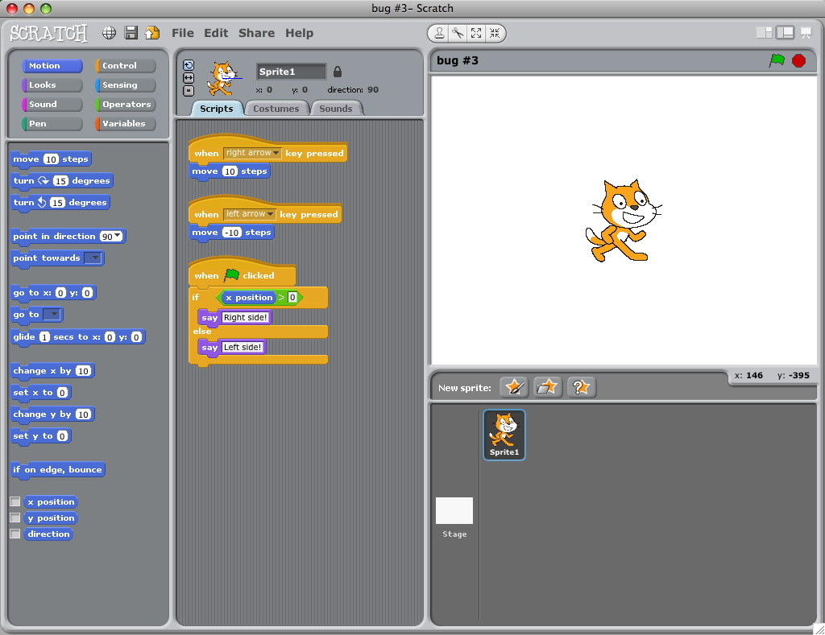

BUG #5
Todd wants his cat to jump up and down, and then move across the screen. But the cat’s hopping across the screen! What’s going on?



