Plan for my final project

Name: | Student

A description of the project that I want to create:
A ping-pong game between a player and a computer. I will need to make sure the computer is smart, but can also make foolish mistakes like a regular human. I will also need to balance out the sides and make sure each player has the same chance of winning.
The steps I will take to develop my project:
- Make the ping-pong desk. I am thinking the bored will be black and a white stripe will be the midpoint segment.
- Create a player with a paddle (line)
- Create a computer that follows “ball” everywhere but can also make mistakes. This will be a pretty hard step.
- Make the ball bounce when it hits the x-axis lines. When it hits the y-axis, the paddle who touched it last gets the point.
The resources (e.g. people, sample projects) I already have to develop my project:
Some resources I already have are:

- User created projects
- Peers
- Google for resources
- Teacher for help
The resources (e.g. people, sample projects) I might need to develop my project:
Some resources that I might need are:

- Brainstorming on desk/player paddles
- Online research

Sketches of my final project

Name: | Student

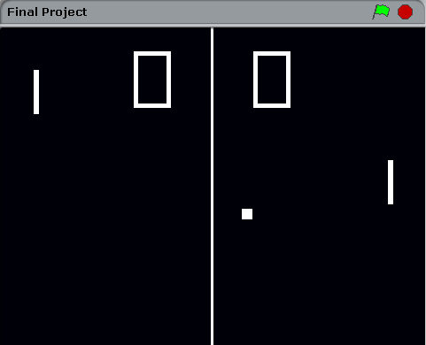 |  | 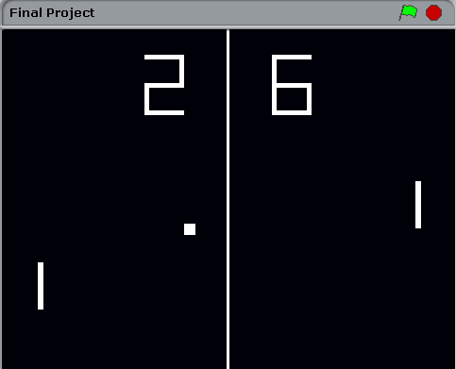
What’s happening?  What are the important elements? |  | What’s happening?  What are the important elements?
The player is controlling the left paddle, while the computer is controlling the right. The score is (0, 0) at the moment. Some important elements are that the computer is following the ball around. |  | This picture shows that it is possible to score on the AI. He is beating me by 4. As you can see, it is quite difficult to score on the AI.
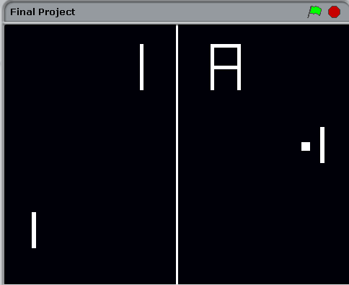 |  | 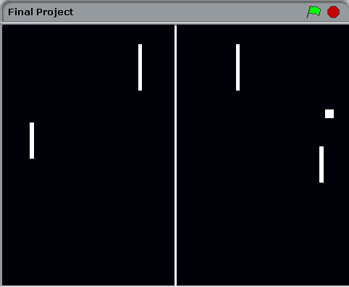
What’s happening?  What are the important elements?  This picture indicates that after the player and/or computer scores over 10 points, the count switches from numbers to letters |  | What’s happening?  What are the important elements?  In this picture, it clearly shows that the computer can make mistakes as well. Proof!

Project feedback

Feedback for: | Student
Feedback by: | -

Parts of the project that I really liked |  | Parts of the project that I would  fix or change or add
- Trained computer to correctly bounce the ball back  - Keeps the score going  - An endless and addicting game to play  - Easy to make |  | - Make a difficulty setting to ask the player if he would like to play on Easy, Normal, Hard, or Insane.  - Add a timer to each round.  - Make the background a little different. In my opinion, it looks too plain.

Parts of the project that might be helpful to think about:
- Clarity: Did you understand what the project is supposed to do?
- Features: What features does the project have? Does the project work as expected?
- Appeal: How engaging is the project? Is it interactive, original, sophisticated, pretty, funny, or interesting? How did you feel as you interacted with the project?

My project reflections

Name: | Student

What?
What is your project?
How does it work? How did you come up with the idea?
I came up with the idea by going on Google and looking at user scratch projects. At first, I was going to create a simple guessing game but then thought how I can take this to the next level. I was deciding on a game that would be endless. Ping pong...
So what?
What was your process for developing the project?
What was interesting, challenging, and surprising? Why?
What did you learn?
The interesting part was actually coming up with the idea. I was just sitting in class one day and decided to make a ping-pong game with an AI. The challenging part was actually configuring the computer so it would
- Be smart
- Make mistakes
A surprising part was that I finished. During this project I felt like I was ready to quit.
Now what?
What are you most proud of about your project? What would you change?
What do you want to create next? Why?
I would like to create a FPS game because it seems more challenging and I like to take challenges. I would definitely change the setting of the game. For instance, with the FPS game I would want different backgrounds (In desert, on grass, in water, etc)
I like my project because it is pretty much endless.

