Name: ­­­­­­­­­­­________________________________ Class: _______________

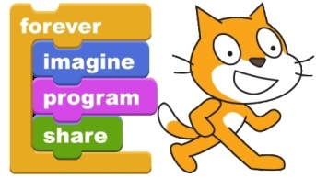 ***4th Grade Technology Scratch Project***

Overview: We will be programming a computer game that incorporates information about the scientist or inventor you studied this year AND helps communicate to new students what Scratch is capable of creating.

Scientist/Inventor: _____________________________

*While most work will be done at school, the planning must be done at home.*

Planning: Identify the four game design elements that will be found in your program.

|  |  |
| --- | --- |
| 1. **Object** |  |
| What is the goal of the game? (ie collect coins, get through the maze, score points, etc.) |  |
|  |  |
| 1. **Operation** |  |
| How do you play the game? (ie Do you use keyboard keys to move? Press the spacebar to jump? Move the mouse around? etc.) |  |
|  |  |
| 1. **Obstacle(s)** |  |
| What’s the challenge that you have to overcome? (ie bad guys, a timer counting down, running out of fuel, life meter, etc.) |  |
|  |  |
| 1. **Outcome** |  |
| What happens so you know you won or lost? (ie “You Won!” screen, “Sorry, you lost” screen, celebration dance, etc.) |  |

Example: An idea for a game based on Benjamin Franklin.

*Object* - Collect the kite, string, and key needed to recreate his lightning-electricity experiment.

Operation - Use the arrow keys to move back and forth across the ground.

Obstacle(s) - Lightning falls down from the sky and tries to zap your character. Each time you get zapped, you lose a life. The kite, string, and key show up for only few seconds and then disappear.

Outcome - A WIN! screen shows up if you get all the items, or a LOSE! screen if you run out of lives. On both of them is a note telling players that the lightning-electricity experiment was actually a myth.