Today’s file is called Exploring Coordinates.sb. In it you will find a background and a Sprite that looks like a dot. The script on the dot is similar to the script listed below and uses the variables listed to the right. The first part of today we will be answering questions about this script. This does not involve opening up the script just yet.

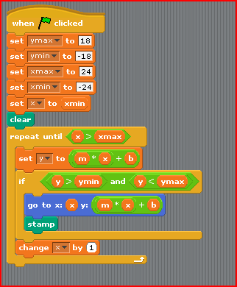
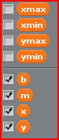

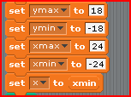
- What is the term we use for these first 5 commands of this script:

- Let’s assume that m=2.0 and b = 3.0. Compute y=m*x + b for at least 10 – 15 of these x values. The more you write down the easier it will be for you to answer the next few questions.

- Recall that the initial value of ymin= -18. Find the smallest x value so that the following is true:
m * x + b > ymin
- Recall that the initial value of ymax= 18. Find the largest x value so that the following is true:
m * x + b < ymax.

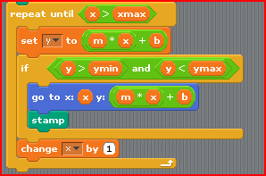
- Knowing these values, let’s examine the part of the script below.
Aside: What type of expression is this called?
We’re going to learn a technique called “hand execution.” Recall that the initial value of
x = xmin = -24. Which side of the graph will you start plotting – the right or the left?
When does the sprite actually leave a stamp?
Using the graph below and the table you computed above, step through the commands in the loop and draw what happens on the graph.
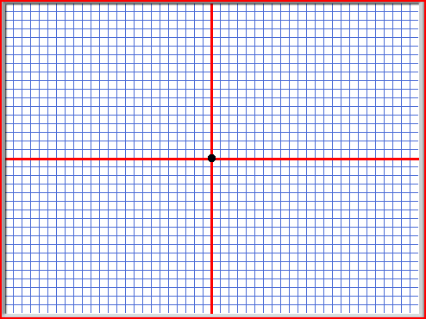\
- The script listed above isn’t *exactly* right for the computer. Open up the file Exploring Coordinates.sb. You will see the following on the Script panel for the sprite:
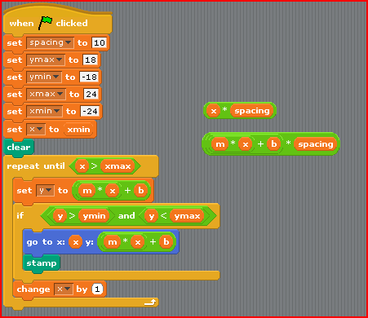

Run the script and draw what you see on the screen on the grid below.
Notice there is a new variable spacing which has been set to 10 at the beginning (what’s that word we use again?) It turns out each grid line is 10 pixels apart. There are two other script snippets x* spacing and (m*x + b) * spacing.

Homework: Fix the script so it runs like your “hand execution” from page 3. This may take some trial and error.

