At the end of last week’s session with Scratch we wound up with a script that drew a line in our window. In the bottom right hand corner there are two variables:

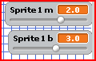

- For each of the next 5 graphs, change the m and b and write down what you changed them to
Run the program and draw the results on the graph next to it. Make sure to try a few with negative values!

m __________

b ___________

m __________

b ___________

m __________

b ___________

m __________

b ___________

m __________

b ___________

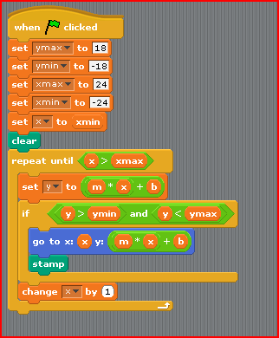
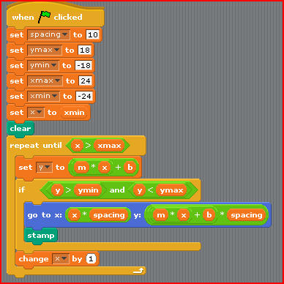
- Remember from last week, we started out drawing without spacing, then we spaced the stamps 10 pixels apart so the line up on our “grid.” Our Here is our script before and after our changes.
A B
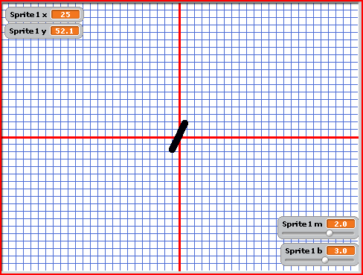
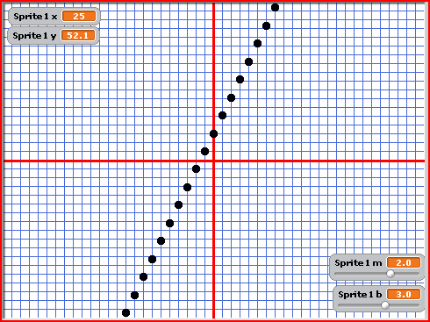
- Write down the following

 | X-Coordinate | Y-Coordinate |  |  | X-Coordinate | Y-Coordinate
Left most stamp |  |  |  | Left most stamp
Right most stamp |  |  |  | Right most stamp

- What is the relationship between the left most stamp in A and B? Does the same relationship hold for the right most stamp in A and B?

x-Coordinate of left hand side of the grid |  | xmin
x-Coordinate of right hand side of the grid |  | xmax
y-Coordinate of the top of the grid |  | ymax
y-Coordinate of the bottom of the grid |  | ymin
- Fill in the following

- What’s the relationship between the x coordinate of the left and xmin? The x coordinate of the right and xmax? The y coordinate of the top and ymax? The y coordinate of the bottom and y min?
- Brainstorming session: As a class let’s come up with some ways we could “fill in between” the stamps. Write our ideas down here.

- Modify your script to make the stamps “draw” as if they were in one line. SAVE YOUR FILE!!!!!!

Quadratics

- First! Save your file as Exploring Quadratics.sb.

- Before we begin let’s do a little review. The equation

y = (x + 1) * (x + 2) can also be expressed as y = x²+3x +2

- Convince yourself that this can also be expressed this way:

y = (x * x) + ( (3 * x) + 2 )

- Create these expressions in Scratch by doing the following. Go to the Numbers and Variables section and pick the correct expressions and variables to put the following two addition expressions together

- (x + 1) (x + 2)

Now combine them with a multiplication expression.

(x + 1) * (x + 2 )

- Do the same for y = (x * x) + ( (3 * x) + 2 )

(x * x)
(3 * x) then take that and add 2: to make

Now combine them with an addition expression

Show Dr. Bricker your work.
- Now let’s look at our script again. Right now it still draws a line using our standard linear equation y = m*x + b. Circle the lines in this script that calculate what each y values are in the loop.

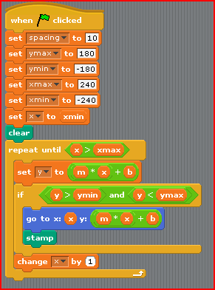
Notice something: Right now we calculate the y value twice in our script as it is written. This isn’t really optimal because the computer has to do all these calculations two times for each x value, and this can take longer.

You can “optimize” this script by not doing this calculation twice but instead using the y variable which is previously set.

Change your script to use y instead of the linear equation in the second spot in your script!

- Substitute your new quadratic equation for your linear equation (what you circled above). Run your program and draw the result on the graph below.

- Now substitute your other quadratic equation in that same spot that you circled before. Run your program and draw the result on the graph below.

What is interesting about the two graphs? Is this what you expected from the way the equations were created?

Bonus: Substitute your variable m for the 3 and your variable b for the 2. Try modifying your equation using the sliders on your m and b variables in your Stage.

- Homework – You will do this for 2 equations!

- Create a quadratic equation by coming up with your own factors (i.e (x + 3) * (x *2)) and multiply them out. Write these here:

- Build up each of the two equations (in either form – the factors or the quadratic equation) in your file and SAVE YOUR FILE so you can show Dr. Bricker next week.
- Substitute each of the new equations in that same circled spot. (where y is calculated in the script. Run you’re the program after you’ve done that. Show each of the results on the graphs on the next page.

- Bonus : try multiplying your whole equation by a number or dividing it by a number. What happens? (x + 1) * (x + 2) * 4 or (x + 1) * (x + 2) / 2
Equation:

Equation:

