SCRATCH Project 1: Draw a Square |  |  | SCRATCH Project 1: Draw a Square
Page 1  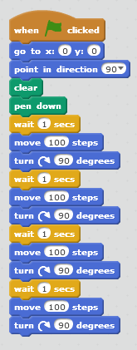 | Events  Motion  Pen  Control  Motion  Change 10 to 100  Change 15 to 90  Your stage will look like this  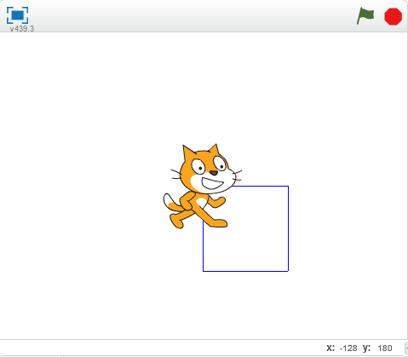 |  | Page 1 | Events  Motion  Pen  Control  Motion  Change 10 to 100  Change 15 to 90  Your stage will look like this
"Scratch is developed by the Lifelong Kindergarten Group "Scratch is developed by the Lifelong Kindergarten Group
at the MIT Media Lab. See http://scratch.mit.edu". at the MIT Media Lab. See http://scratch.mit.edu".

SCRATCH Project 1: Draw a Square  Shortcut: Use the "duplicate" feature |  |  | SCRATCH Project 1: Draw a Square  Shortcut: Use the "duplicate" feature
Draw a Square:  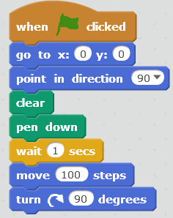  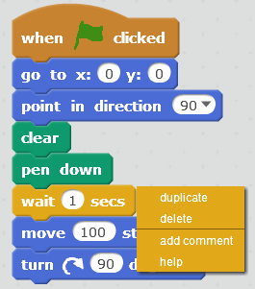 | Same as before  Right click Here  Click "duplicate"  and drag the new commands here  NOW Do it again! |  | Draw a Square: | Same as before  Right click Here  Click "duplicate"  and drag the new commands here  NOW Do it again!

