EVERYTHING ON THIS PAGE is code for the convertible sprite.
Choose a new sprite: One of the convertibles  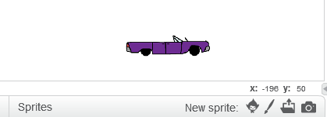 | Create a new variable called "Score"  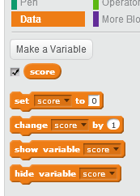
Write code to place the car, make it a little smaller, and set the score to zero.  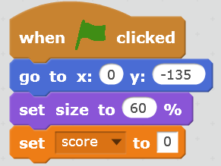  Make it smaller  Place the Car  Set the score to zero | Write code to move the car when the arrow keys are pressed.  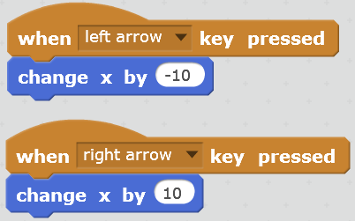
You can have more than one code string for a sprite. The whole thing should look like this: TEST YOUR CODE. Does the car move like it should?
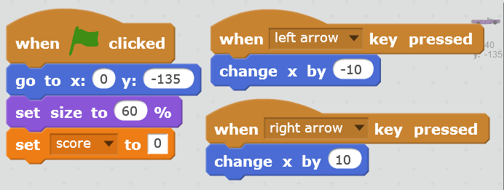
The car will control when snowflakes are released. Put this code in to do that:
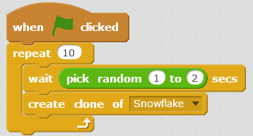
OPERATORS
The rest of the blocks are in CONTROL
"Scratch is developed by the Lifelong Kindergarten Group at the MIT Media Lab.
See http://scratch.mit.edu".
EVERYTHING ON THIS PAGE is code for the snowflake sprite.:
Create a new sprite – choose the snowflake  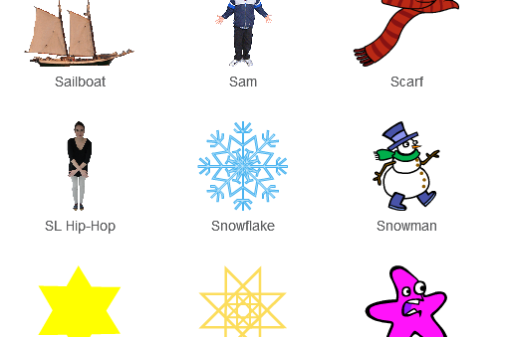 | You will have 2 code strings for the snowflake. Here is the first.  (Make sure the snowflake is highlighted)  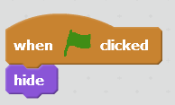
Here is the second.
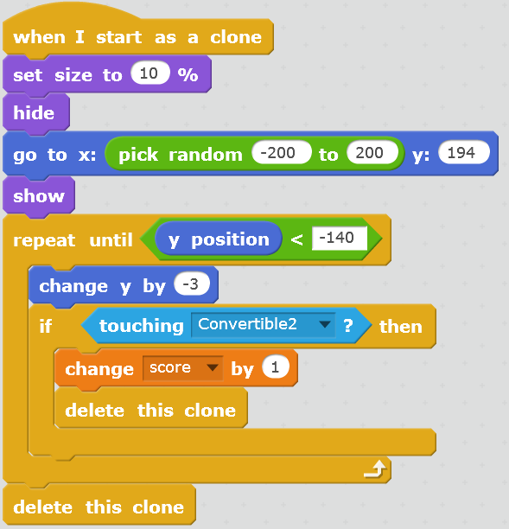
OPERATORS
LOOKS
LOOKS: Make the snowflake smaller
CONTROL: Not the usual hat block
This gets rid of any snowflakes that make it to the bottom
This gets rid of the snowflake after it touches the car
This gives a point when the snowflake touches the car
This makes it fall
This makes the snowflake appear randomly at the top of the stage

