**INTERACTIVE HOLIDAY CARD**

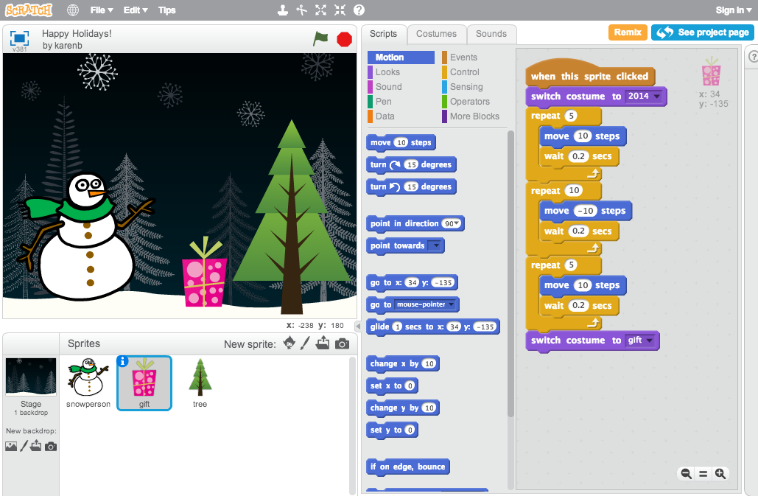

Combine interesting images and sounds to create an interactive holiday card that you can send to someone you care about.

For more help, follow the full tutorial (with videos) at http://scratch.mit.edu/hoc

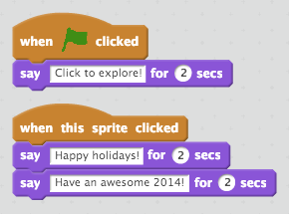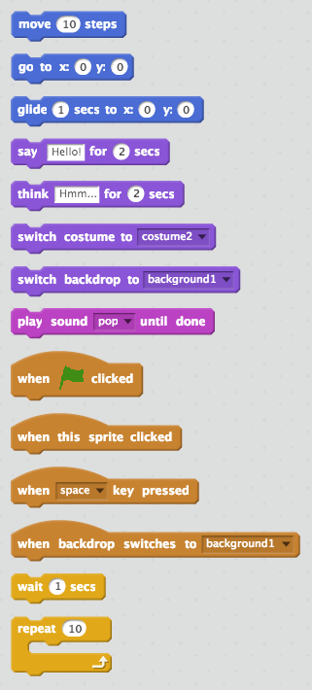­­

make your sprite interactive by adding scripts that have the sprite respond to clicks, key presses, and more

**2. Make it interactive**

**BLOCKS TO PLAY WITH…**

take a picture

paint your own sprite

import an image

**5. Send your online holiday card by sharing the link with family and friends.**

**4. Share your project and add it to the Hour of Code studio:** http://scratch.mit.edu/studios/279432

**3. Repeat steps 1 and 2 until you’ve achieved your creative vision!**

**STEP BY STEP...**

**1. Add a sprite**

choose a sprite from the library