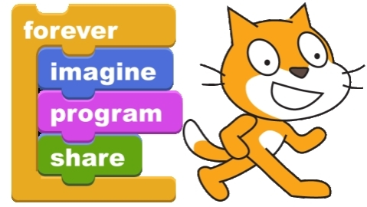 | Inventing Video Games with Scratch

Scratch is a programming tool developed by the Media Lab at MIT. It is designed to be easy to use by students, teachers and even parents. Scratch allows anyone to give instructions to objects on the computer screen. | Scratch is FREE – download it (for Windows, Mac or Linux): http://scratch.mit.edu
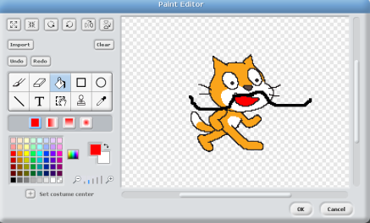
Scratch allows you to create games, animations and other programs by importing or drawing graphics for the background (on the stage) and for different sprites (characters or buttons on the screen). There is a built in painting tool that makes it easy to create and change your images. You can add sounds by importing them or recording off your computer.
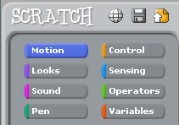
Then you can make your graphics come to life by adding scripts. Scripts are created by dragging script “tiles” from the library into your sprite’s script area. Scripts are an easy way to learn how to program a computer. In the digital age it is important that everyone learn to speak the language of the computer so we can better understand all the gadgets that surround us. Scratch is a fun way to learn 21st Century skills and share your creativity with your friends.
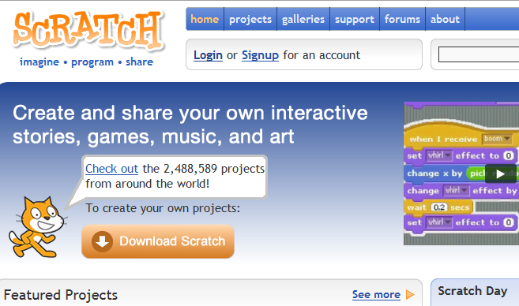
If you create an account (free) you can share your scratches by uploading them to the MIT website with the share button. On the website you can look at the over 2 Million projects that have been uploaded already. Any project on the website can be downloaded and modified so you can build on what other scratchers have done. Comment on people’s games and join the worldwide scratch community.

Game #1 – Speed Racer

- Start a new project  - Go to the Background for the Stage – Paint a new costume | 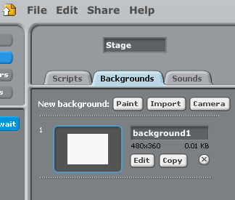
- Paint a track that looks like this  - start with the paint can  - use the big brush | 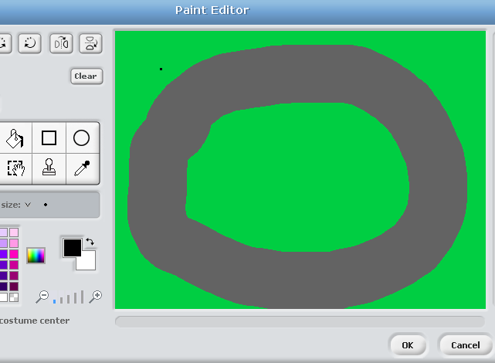
- Go to the Costume for Sprite1 – Import a new costume – get a car  - Use the Shrink tool to get your car down to a good size | 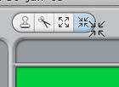
- How to make the car turn? Use the arrow keys  - How to make the car move? Start with the green flag  - Use the move block inside a forever loop | 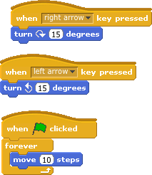

Try it out! You have made a game!
Is it too fast? How can you slow the car?

Speed Racer Extras:

- Control the speed  - Create a variable called “speed” (select “for this sprite only”)  - Put the speed into the move block  - Use the up arrow and down arrow to change speed  - Set the initial speed | 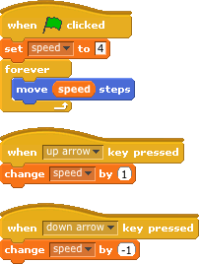
- Countdown  - Create a countdown sprite with three costumes (3, 2, 1)  - On the green flag start the countdown  - At the end broadcast a message to start moving and hide  - Change the car (Sprite 1) script to receive the message  - Place the car at the starting spot and face forward before moving  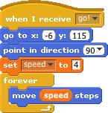 | 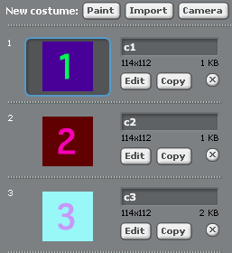  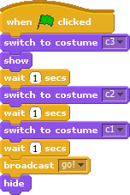
More ideas
  - Add a second car (hint – use the asdw keys)
  - Count laps
  - Measure the time to complete a lap
  - Make a list of the fastest times

