Name: Date:
Design & Technology 9 Section:

Scratch Do Now 1
Directions: For each block, list what you think it will do. An example is provided.

Block | What do you think this block will do?
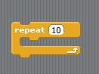 | Example:  Whatever instructions are inside this block will be repeated 10 times.
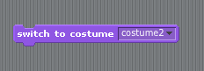 | 1.
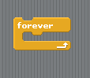 | 2.
 | 3.
 | 4.

