Name: Date:
Design & Technology 9 Section:

Scratch Do Now 2
Directions: Match each combo block with what it will do. Then write a summary of what the program does.

- This combo block checks to see if the variable “switch” has the value 1, and if it does, it plays the sound “meow” for the rest of the program. Block _________

- This combo block sets the value of the variable “switch” to 0, when the green flag is clicked. Block _________

- This combo block checks to see if the variable “switch” has a value greater than 1, and if it does, it stops all sounds for the rest of the program. Block _________

- This combo block changes the value of the variable “switch” by 1 every time Sprite1 is clicked. Block _________

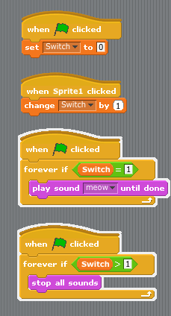
D
C
B
A

Summary:

