Name: Date:
Design & Technology 9 Section:

Scratch Do Now 5
Directions: Look at the program shown below. Think about what each combo block will do. Then write an explanation on the following page.

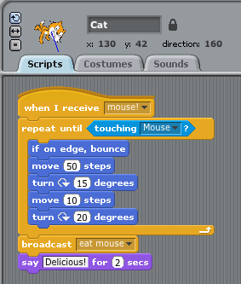
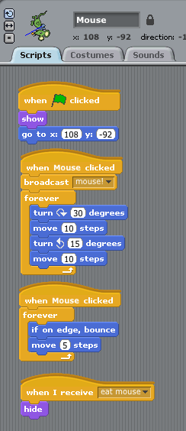

The two screenshots on the front page show a program for the Mr. Meow sprite and a mouse sprite. What does this program do? Explain step by step. Some prompts are given to help you.

When you press the green flag, the program starts playing. The first thing that happens is

If you click the mouse sprite, three things happen:

1.
2.
3.

When Mr. Meow receives the signal “mouse!”, he will

If Mr. Meow touches the mouse sprite, he will

