Name: Date:
Design & Technology 9 Section:

Scratch Do Now 6
Directions: Look at the program shown below. Think about what each combo block will do. Then write an explanation on the following page.

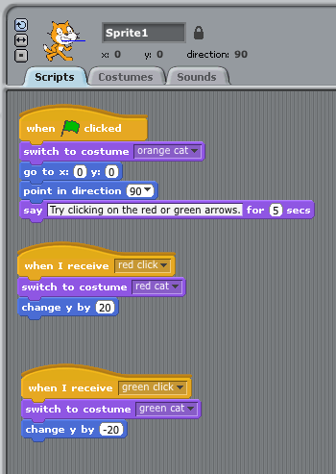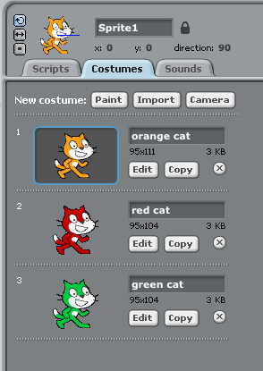

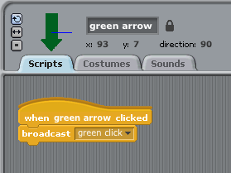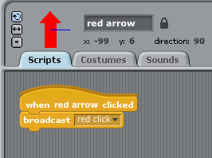

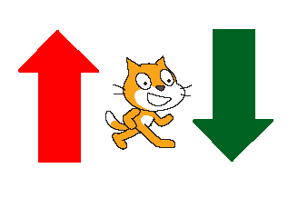
The screenshots on the front page show a program for the Mr. Meow sprite and two arrow sprites. What does this program do? Explain step by step. Some prompts are given to help you.

When you press the green flag, the program

If you , then

If you , then

