Name: Date:
Design & Technology 9 Section:

Pen Exploration
Directions: Explore the blocks in the Pen menu (shown below). Use this page to take notes about what each one does. Try them out in small programs to see what they do!

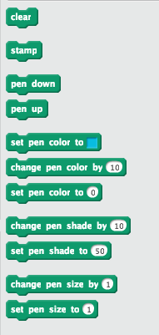
Name: Date:
Design & Technology 9 Section:

Sensing Exploration
Directions: Explore the blocks in the Sensing menu (shown below). Use this page to take notes about what each one does. Try them out in small programs to see what they do! One example of the kind of small program you can make is shown on the left below.
