Computational Thinking with Scratch
Vocabulary Quiz
Fill in the blanks with one of the following Computational terms.

collaborate | remix | script | debug | instructions

Alex wants his cat to dance to some music. But the cat is dancing after the music is over! What’s going on?
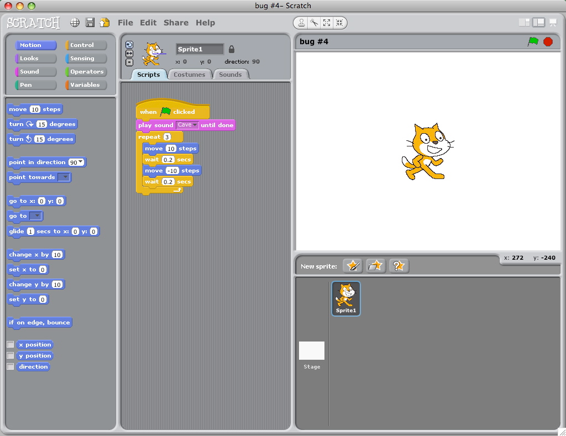

Alex’s Scratch project is not working the way he planned. Alex will have to test his project again to find and fix problems to be able to __________ it. First he should review his ____________. If he needs help he could_______________ with someone else or he could read the ___________ sheet the teacher handed out to everyone. Lisa liked Alex’s project idea so she downloaded it to her computer and did a ___________ of it, changing it around to make it her own.

Computational Thinking with Scratch
Vocabulary Quiz

Match the letter with the correct definition.

A.  Computational Thinker | B.  Scratch | C.  parallelism | D.  stage | E.  import

________1. ‘Things’ happening at the same time

________2. To bring in

________3. A programming language developed at MIT.

________4. The background of a project

________5. Someone who uses different strategies to problem-solve

Computational Thinking with Scratch
Vocabulary Quiz
Circle the correct answer choice
1. To add a project to Mrs. Youngman’s closed gallery she will first have to…

a. see if she likes your project
b. friend you
c. like you

2. Mrs. Ross had a plan of action to achieve her project goals if she got stuck. She listed all of her________in her design notebook.

- strategies
- issues
- problems

3. To find Scratch online you can type in this____ in the address bar.

a. word
b. URL
c. link

4. When Ian made his final Scratch project, he developed a little bit and then tried it out and then developed some more. He created step by step. Ian was…

- being safe
- being iterative
- being collaborative

5. Julie asked “what is the name of the Objects that perform actions in a Scratch project?”

- icons
- sprites
- stuff

