Bees And Bananas!

We are going to make a game where you are a cat. You are a crazy cat who likes bananas. The problem is, there are some bees who like stinging you! So, you need to eat the bananas but try not to get stung by the bees.

1. Let’s get started

Open Scratch and make sure we are starting a New Project. If you need to, click “File” then click “New”. Your screen should look a lot like this:
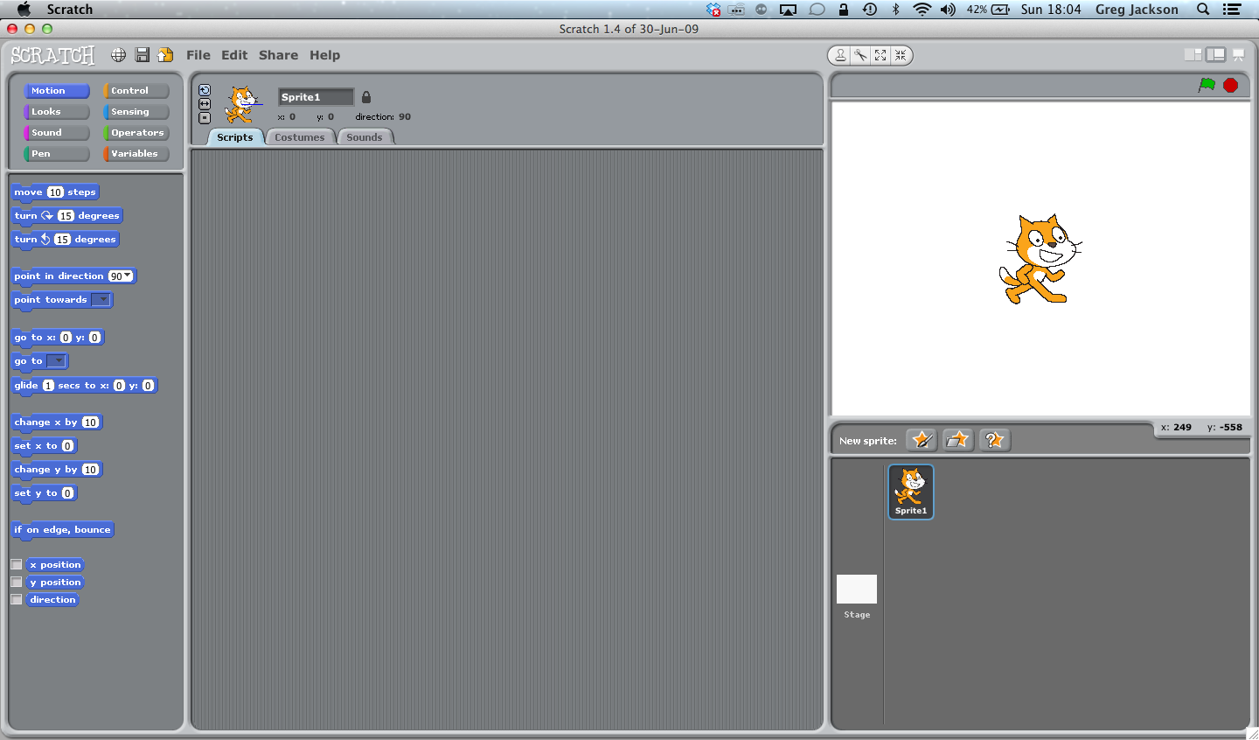

2. First, we need to give our cat a script so we can move it around.

Click on the cat so that we are writing a script for it:
Click the cat here so that we are writing a script for it

One cool way we will be able to move our cat around is to have it chase the mouse pointer. Here’s a script that will do that…

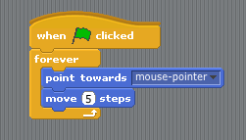

Make this script, and then try clicking the green flag. Move the mouse pointer around, and see what happens… By the way, did you make it “move 5 steps”?!

OK. This is cool, but gets boring quickly. We said the cat was going to try to eat bananas. Let’s add the bananas!

3. Add Bananas
Click the middle star button underneath the stage to “choose a new sprite from file”:

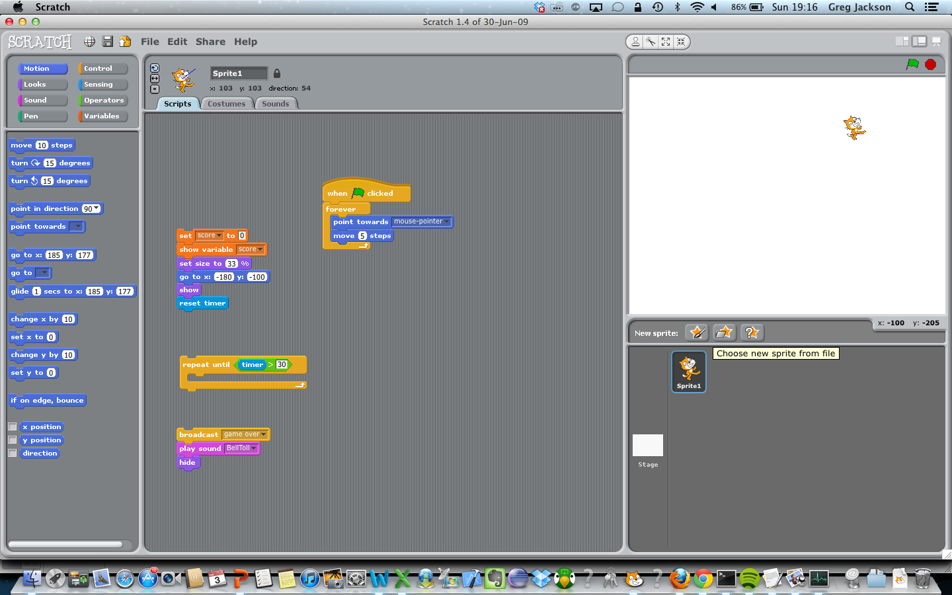
Click here to choose a new sprite.

Then choose Things:

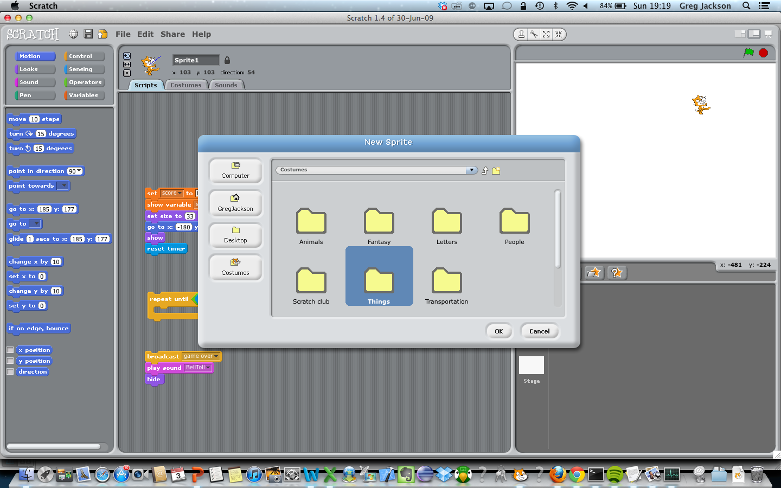

And then choose bananas1 and click OK:
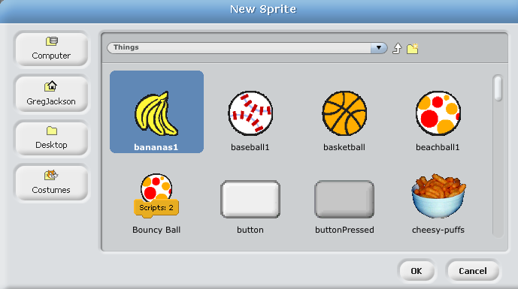

The bananas should now be Sprite2 in the Sprites area at the bottom right hand side of your screen, and you should be able to see the bananas on the stage. Double-click on the bananas in the Sprite area to make sure we can write a script for the bananas. You can check this by making sure the bananas in the sprite area have a blue box around them, and that it says “Sprite 2” at the top of the script area.

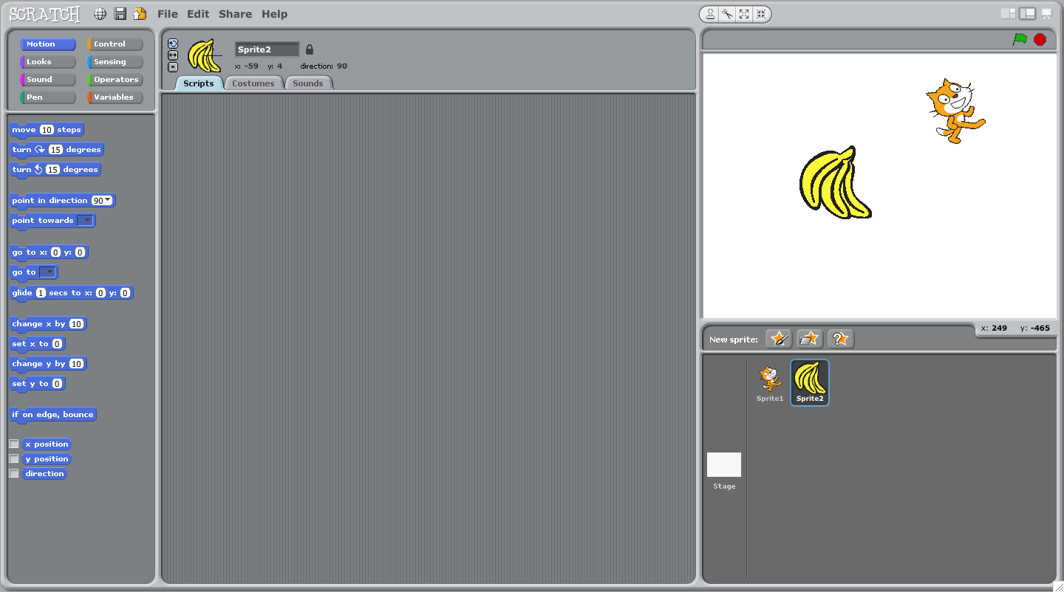
Double-click the bananas here to make sure we are writing a script for the bananas.
Notice how it says “Sprite 2” underneath them (and the cat is Sprite1)

Now let’s make a script for the bananas:

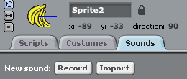
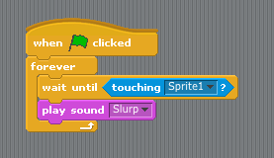
Do you know where to find the sound “Slurp”?
Hint: click on the word “Sounds”, then click
Import. Choose “human”
and then find “Slurp”
Remember to click “Scripts” afterwards!

Once you’ve done that press the green flag and give it a try.

Does the cat follow your mouse? What happens when it gets to the bananas? (hint: are you wearing headphones?)

After you’ve had a play, press the red stop button and let’s make it more fun…

4. Let’s add a score

OK. All games need scores. Here’s how we add one to ours:

First, double-click on the cat to make sure we’re editing the cat script.

Now click on “variables” and then click “make a variable”:
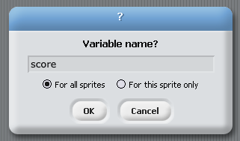
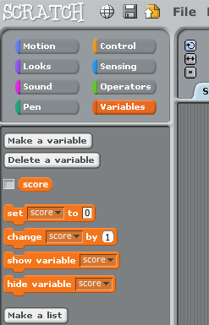
Then click “make a variable”

Click variables

When it asks for a name for the variable, type
score
and press OK.

A variable is just a box where we can keep a number. This box is called “score” and we will keep a number in it. The number we keep will be… the score of course!
Now change the cat script to look like this:
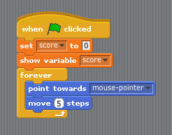
set score to 0 - because score should start at zero

show variable score - so we can see our score!

Now go to the bananas script and add a new line to change the score when the cat is touching it.
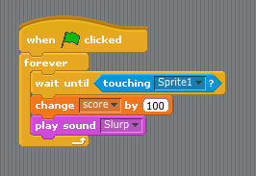
Each time the cat gets the bananas, let’s increase the score by 100 points.

(REMEMBER: this needs to go in the bananas script!)

NOW PRESS THE GREEN FLAG AND TRY IT OUT.
Can you see the score shooting up all the time the cat is touching the bananas?

Let’s do some other cool things with the bananas. Let’s make them move whenever the cat gets them.

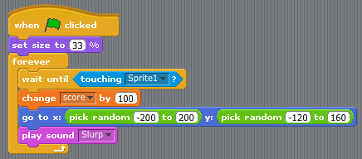
This bit is trickier!
First, choose
Then choose
Now choose
Then grab
Drag the “pick random” over the x: number and then again over the y: number on the blue “go to” block
Now change the numbers as shown
First, let’s make the bananas smaller

Click the green flag and have a play… see how the bananas work.

Look at the bananas script and see if you can work out what this line does:

5. Add a time limit to make it harder!

Go to the cat script and change it to look like this:
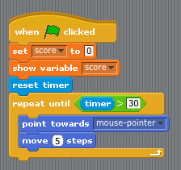
You can find “timer” under
First, click to show the timer on the stage
Now drag - it will make the timer start at 0
And now change the “forever” to “repeat until”. You can drag into the “repeat until” piece and add the timer and the number 30

Now the cat will only keep chasing the pointer while the timer is less than 30. So after 30 seconds the game will stop.

Test it again… and see how many points you can score in 30 seconds…

6. Let’s add a bee to make it even harder!

Click on “Choose a new sprite from file” (hint: we did this to get the bananas…)

Click on “animals” then choose “bee1”

Now make sure you are making a script for the bee and create this script:

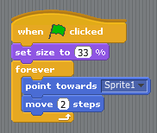
Can you work out what this script will do?

Why does it point at Sprite1 ?

Try it out…

Does the bee chase the cat? What do we need to do to make it more fun?

Let’s make it so you lose points every time the bee catches the cat…
Choose the cat script and change it to look like this:

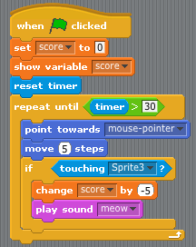
This bit checks to see if the cat is touching the bee.
If it is the player loses 5 points – and the cat meows because it doesn’t like bee stings!

Try it out! It should be pretty fun by now and you can see how good a score you can get…

7. Let’s finish the game by adding another nasty bee!

This bee won’t chase the cat, but will buzz about, getting in the way.

First, add another sprite from file – and again choose a bee. This sprite should be Sprite4.
Now write this script for the new Sprite:

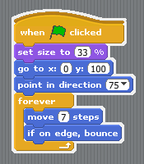

Then go to the cat script and add some lines to check to see if the cat is touching Sprite4:

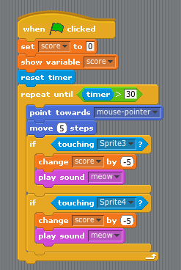
These are the new lines…
Can you work out what they do?

And test the game again…
Is it getting harder to score now? More fun?

OK. We’ve made a pretty cool complete game. But if you want some challenges…
Easy:
- can you make the cat move faster or slower to make the game easier or harder?
- can you make the bees move faster or slower to make the game easier or harder?
- have you got any other ideas that might make it easier or harder?
Medium:
- could you add any other bees?
- more bananas?
Hard:
- could you make a bee that ‘guards’ the bananas by circling around them?
- could you convert it into a two player game where player 2 uses the keyboard to move a bee. Of course, you’d need to add another score…

