CONTROLLER GLOVES FOR MAKEY MAKEY
Version 1
I made these gloves to use with Makey Makey and Scratch. I used an old pair of woollen gloves initially but then reviewed the design and build. I only had one pair of gloves so I used each one for a different build.
First, I used tin foil.
I cut thin strips of foil, long enough to run from the tip of the finger all the way to the cuff of the glove. I used hot glue to stick the foil in place. On each finger pad I used a larger square of foil. The thumb acted as the earth.
Squares of foil on finger tips, foil from back of finger comes over top.
Lines of foil down back of fingers -coming over top of fingertips & down to cuff.
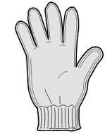
Square of foil on thumb; line of foil down to cuff. This is the used for the earth.
Version 2 used conductive thread and material.
The glove worked fine but the woollen glove was too stretchy for the foil and minor repairs were needed almost immediately.
Here, you can see the first glove.
Version 2
Version 2 used the second glove of the pair but this time I used small tabs of conductive material and thread to replace the foil.
Each fingertip had a small patch of conductive material sewn with conductive thread.
Down the inside of the thumb a line of conductive thread was sewn, which connected with a tab of conductive material where the crocodile clip can be attached. I tried as much as possible to keep the thread on the ‘outside’ of the glove rather than sew ‘through’ the material, so that the user’s hand wouldn’t interfere with the flow of current.
Here you can see the line of conductive thread down the back of the finger & connecting to a tab of conductive material.
The first person to use this glove found that their own hand interfered with the flow of current. Solution: change the crocodile clip to connect with the patch of material on the fingertips rather than the tabs further down the backs of the fingers. This worked fine but other users didn’t have the same issue and used the tabs.
Version 3
For the next version of the glove I used a cotton gardening glove.
The woollen glove was too stretchy for the foil and users had to be really careful about getting it on and off which lead to minor repairs being needed fairly frequently. The second version had the problem that the conductive thread was too ‘close’ to the user’s hand and despite my best efforts it was difficult to keep the thread on the ‘outside’ of the glove and away from the hand. I decided that cotton gardening gloves would be thicker, less stretchy and might be better at keeping the user’s hand away from the conductive material. But then I had a better idea…metal buttons and bell wire!
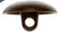
For version 3 I used metal buttons sewn onto the fingertips of the glove. Then I stripped back just 1 cm of the protective plastic so that I could wind the wire around the loop of the button.
Next, I split the wire so that one strand ran down one finger. At the base of the fingers I left the wire joined and ran it down the palm of the glove to the cuff where I secured it with a few stitches. At the cuff I again stripped back just 1cm of the plastic to reveal the wire and wound the wire into a loop so that the crocodile clip could attach to it.
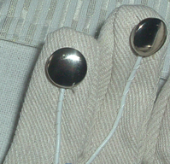
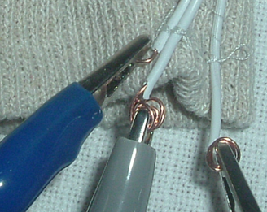
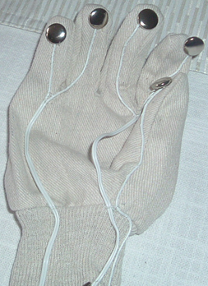
Wires were sewn down on the finger but not down the palm to allow for flexing of the glove.
Wire split and sewn down one finger…
…unsplit wire running down palm to cuff…
…just enough wire exposed to wind into a loop for crocodile clips.
The metal buttons make a very satisfying click when used!

