The Crab in the Maze

Delete the Cat and add in a Crab by pressing the Add New Sprite button | 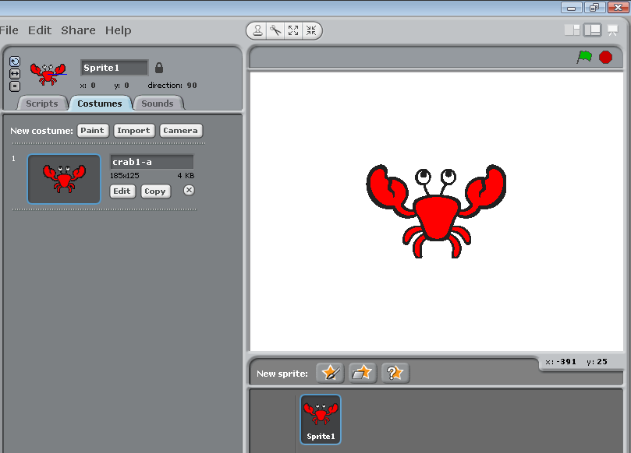
Paint the sprite to include a blue dot on the head of the crab. We will be using this to sense the path.
So it ends up like this. | 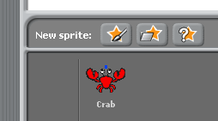
Paint a new sprite for the Maze. Zoom out as far as it will let you.  Use the rectangle tool to draw a simple yellow maze, like opposite. Make sure there is a gap all the way around. | 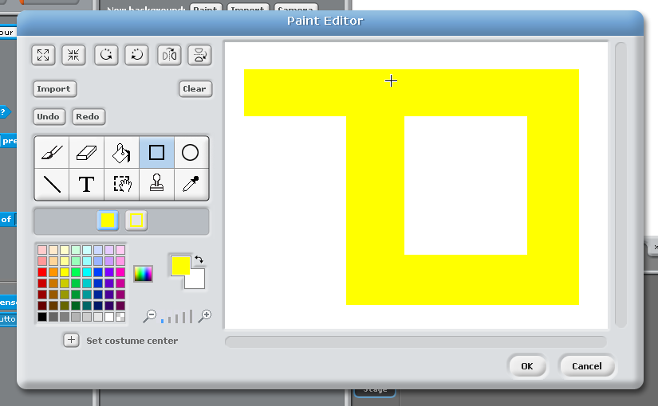
Resize so they fit as shown.
Ensure the crab can rotate by clicking on option.
Add the following script to your Crab sprite.

Controls and movement. Notice the sensing part.
Test it, does it work? If not why not?

How can you fix this problem?
To fix the problem of getting stuck. Make the crab move 3 steps so you can get back on the path.

The next instructions will show you how to get a new level from meeting a goal.
Reset position of Crab at beginning of game.

Also introduce a new level receiving block. This will put the crab to the start position every time you change level.
You are now going to create some more levels for your work and test them out. You do this by adding them to the costume section.  In this example I’m only creating one more. | 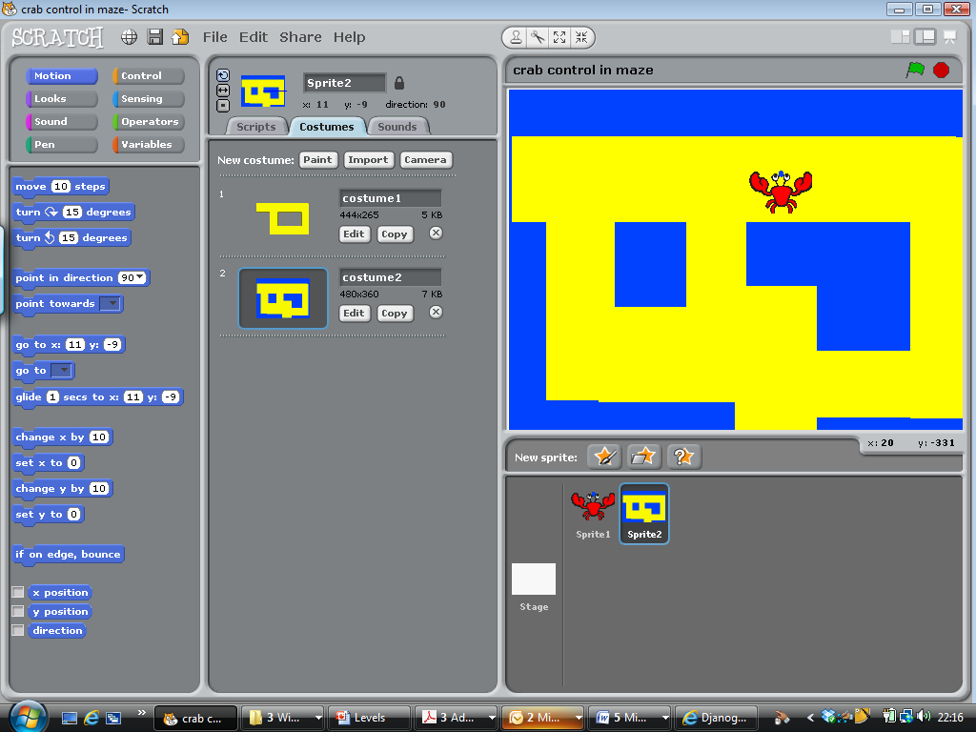
Add a green dot to all costumes. This will be the key to change the level. Make sure you are using the same green on both costumes.
Add this code to the maze sprite and reset the crab position each time by having a broadcast of new level.  This will put the crab back at the start position.  Play the Game.  Challenge:  How about animating the crab so it looks like it’s walking.  What’s missing?  Extend to have those improvements. Level 5/6  Document your project explaining how it works in your own words and if you have extended it. Use template provided. | 