Lesson 6 Dynamic Therapy Game Planner
Name:
Group members:

Persona Mind Map:

Which game concept did your group decide to pursue?

Part 3 - Ideate Phase of Design Thinking

12. Revisit your scenario and mind map. How can you further interpret findings from the scenario and apply it to theme for the game? Make a table of at least 5 piece of information from Discovery and how that is being translated into your game (Interpretation).

Discovery Information | Interpretation

13. How will the game be appealing to the user? How will you make the game artistically appealing? Consider aspects such as graphics, color schemes, storytelling, music, etc.

13. How will you make the experience engaging and motivating?

14. How will your game be dynamic?

15. Mathematically speaking, how will you determine player success? For example, what will determine if a player should move on to a more challenging task? Consider factors like timing, score, etc.

16. What should the game and controller look like? Sketch multiple ideas. With your group, decide which option to pursue or which ideas to combine. Remember, the controller might be better described as a touchpad. How will the Makey Makey be used to interact externally with the Scratch game on the computer?

17. What materials do you need? Who is responsible for bringing what? Record your responsibilities in your planner or where ever you record your homework.

19.What are the roles of your group members?

20. What are expectations of the group members for completing the project?

Lesson 6 Example Exercise Resources

Here are links that show examples of exercises. You can create your own type of exercise for the game as well. Regardless, you will need to explain how your game will help improve the movement for the game player.

Exercise ideas:
Hand/Finger: http://www.m.webmd.com/a-to-z-guides/ss/slideshow-hand-finger-exercises
Hand: http://www.health.harvard.edu/pain/5-exercises-to-improve-hand-mobility-and-reduce-pain
Stroke (starts on page 61): https://www.stroke.org/sites/default/files/resources/NSA-Hope-Guide.pdf
Leg: http://eldergym.com/leg-exercises.html
General exercises: http://eldergym.com/exercises.html
Arm/Hand: https://www.mskcc.org/cancer-care/patient-education/upper-extremity-exercise

More observations:
Stroke patient: https://www.youtube.com/watch?v=AiyQz5_7MLw

Background information:
Stroke:
http://faculty.washington.edu/chudler/vessel.html#stroke

Spinal Cord Injury:
http://www.ck12.org/book/CK-12-Life-Science-Concepts-For-Middle-School/section/11.51/
http://www.nsta.org/publications/interactive/nerves/health_and_disease/sc_injuries.html
http://www.gillettechildrens.org/conditions-and-care/spinal-cord-injury-and-related-neurotrauma/

Lesson 7 Conditionals Practice
Code | Explain how it works
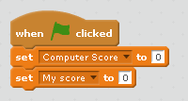
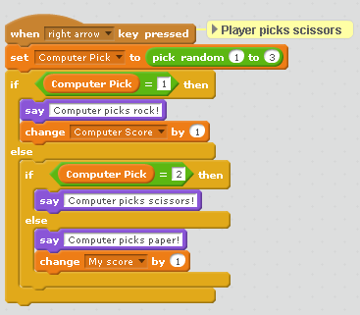
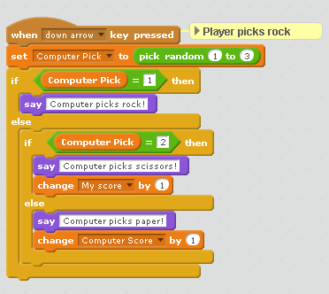
 | Write the code for if the player picks paper. Use the up arrow.
Lesson 7 Dynamic Therapy Game Pseudocode Plan
Group: ________________________

Lesson 8 Dynamic therapy game project rubric

Name: ______________________________

Task | Completed  (10 points) | Did not complete  (0 points)
Completed all game planner handouts
(Lesson 5 and 6)
Coded a therapy game in Scratch
Used pseudocode to create the game
Scratch game was dynamic
Game was designed with the patient’s rehabilitation needs in mind,
Game and controller included elements of art to enhance the project through graphics, color, sounds, music, and/or storytelling
Created a controller with the Makey Makey for use in the therapy game
Sought feedback on project and implemented improvements based on the feedback
Presented the game and explained the connection between the pseudocode, game, and art project during the Maker Faire
Stayed on task during the project, contributed equally to the project, and submitted the project on time

Lesson 8 Feedback Handout Group name: ______________________

Have 2 classmates try your game and then have them fill out the feedback form. Then, analyze the results.

Reviewer name | I like  (Glows) | I wish  (Grows) | What If  (Suggestions/Ideas)

- What changes will you make based on the feedback?

- Based on what you observed as the tester tried your game and controller, what changes do you think need to be made, if any?

Lesson 8 Daily work log and project instructions Name:________________________

During the project, you will apply your knowledge of dynamic games, the nervous system, and conditional statements to create a dynamic game that can be used in physical therapy by someone who has an injury to the nervous system. You will also use the Makey Makey Invention Kit to design the controller or touchpad. The type of game you are designing depends on the scenario you chose. The engineering problem you are solving is how to keep a patient motivated during therapy. Not only should your game keep a player engaged by having it be dynamic, but also by incorporating the arts. The music, graphics, colors, sounds, and theme of your game and controller can also contribute to the success of your solution.

You should also test your project frequently to find areas for improvement. On days 3, 6, and 9, we will take a few minutes to get feedback from other groups, which is a critical component of design thinking. More details about feedback days will be provided on day 3.

Each day, complete the Daily Work Log by using bullet points to fill in the boxes. Use the log to record your progress and set goals for the next day so you know what needs to be accomplished. Reminder: every member should contribute equally. While this is a team effort, individual contributions will impact grades on an individual basis.

Please review the project rubric is to see how to earn full credit for your work. The project is a summative assessment. Your project will be shared in an exciting event called a Maker Faire!

 | Day 1 | Day 2
Today’s accomplishments

List your challenges and
successes

Questions you have

Specific goals for next time

Workstation check off

 | Day 3 | Day 4
Today’s accomplishments

List your challenges and successes

Questions you have

Specific goals for next time

Workstation check off

 | Day 5 | Day 6
Today’s accomplishments

List your challenges and
successes

Questions you have

Specific goals for next time

Workstation check off

 | Day 7 | Day 8
Today’s accomplishments

List your challenges and successes

Questions you have

Specific goals for next time

Workstation check off

 | Day 9 | Day 10
Today’s accomplishments

List your challenges and
successes

Questions you have

Specific goals for next time

Workstation check off

Lesson 9 Making Mobiles Review Name: _________________

- Who was Alexander Calder? What is his major contribution to art?

- What is kinetic art?

- Define the word mobile. It has several meanings. Include at least 3 versions.

- What does it mean for art to have movement? What is the difference between implied and actual movement?

- What does it mean for something to be balanced?

- How does creating the mobile relate to the Let’s Play unit?

- Attach your pseudocode flowchart and your mobile planning diagram.

Lesson 10 Maker Faire Questionnaire!

Thank you so much for attending the Maker Faire! The class is excited for you to see the projects! Below are some suggestions for questions to help guide conversations with students. Before you leave, please consider leaving feedback notes as well.

- How does your game help someone recover from an injury?

- Who is your game designed for and why?

- Where did the inspiration for your game come from?

- How does the code work?

- What is pseudocode and how did that impact your project?

- What role did art play in the creation of your game and controller?

- What is the connection between the mobile sculpture and the therapy game?

- What is design thinking?

- What changes have you made to your project since the first day you started on it? What improvements would you make now?

- What have you learned from this experience?

Please provide feedback for the class! What did you think of the event? What did you like about the projects? What suggestions do you have for the class?

