Making a Simple Game.
If you have done the Bouncing ball exercise and the Cat following Mouse exercise you should be able to make this simple game because it uses similar scripts. The only new part is scoring where you have a timer.
Sprite | Rules
Hero Sprite | Starts in the middle. Follows mouse pointer. Starts with alive costume and then if the enemy touches it then changes to dead costume and stops game.  Object of game is to avoid being touched by the enemy for as long as possible.
Enemy Sprites | Start in the corner of the stage. Moves and bounces off the walls and comes back at a random angle.
Timer | When game reset score to zero and when every second it goes up by one. The longer the game the higher the score.
Challenge: Try and make it yourself and only use help sheet if really stuck. L4/5
Making a Simple Game – Help Sheet
 | I used a cat one but you can choose your own sprite or even draw one. My dead costume is copy of the first one but covered in red to show it has been bloodied after touching the enemy.
I choose this rat like sprite and set its’ position in corner at the beginning of the game. Then just the same code as the Bouncing ball code.

Duplicate to make more enemies.

This makes it rush around like a crazy thing.
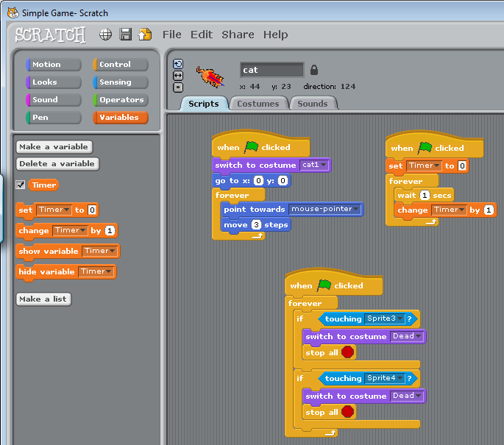 | The cat is placed in the centre and follows the mouse but could be controlled by keys.  Simply checks if one of the enemy sprites touches the cat. If so then changes costume and stops the game.
Challenge: Try to change controls and make different types of enemies who move differently etc. L5 Document your game.

