Maze Game
RULES: Move the sprite round the maze to get to the square marker in the centre without touching the coloured walls.
Start off by creating the background walls and centre square.
Create a new circle sprite.

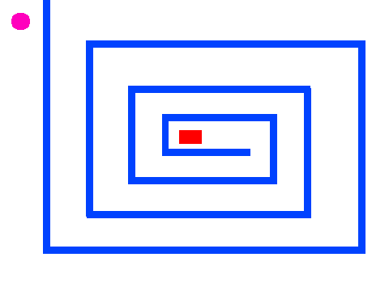

Maze Game
RULES: Move the sprite round the maze to get to the square marker in the centre without touching the coloured walls.
Start off by creating the background walls and centre square.
Create a new circle sprite.

To move the sprite around

Place the sprite at the start point and from this take the x and y positions and use these within the block.
Make the sprite bounce off the walls

Send message when the end point is reached.

To move the sprite around

Place the sprite at the start point and from this take the x and y positions and use these within the block.
Make the sprite bounce off the walls

Send message when the end point is reached.

Creating A Timer

Click on the variables section
Click on make a variable
Call it timer
When this box is ticked the timer will show on the stage

Add the following script in

Creating A Timer

Click on the variables section
Click on make a variable
Call it timer
When this box is ticked the timer will show on the stage

Add the following script in

Scoring
Add in some coloured block obstacles on the maze for your player to avoid.
Create a variable and call it score
In this example the player starts off with points and as they bump into objects they get points deducted.

However scoring can also be used to give the player points in which case the score would be set to 0 instead of 10 and the change score would be 1 instead of -1. Finally you need to decide on the winning score to substitute into the if score= 0 block.

Scoring
Add in some coloured block obstacles on the maze for your player to avoid.
Create a variable and call it score
In this example the player starts off with points and as they bump into objects they get points deducted.

However scoring can also be used to give the player points in which case the score would be set to 0 instead of 10 and the change score would be 1 instead of -1. Finally you need to decide on the winning score to substitute into the if score= 0 block.

