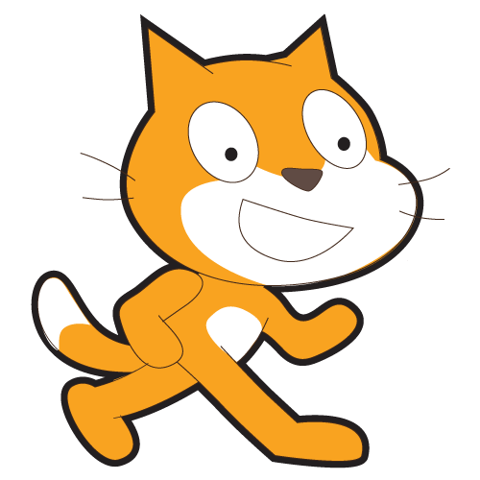­­

Minute of Code: Museum Party!

To check out your character, go to scratch.mit.edu/projects/________

To make your own program, or explore other programs, go to scratch.mit.edu