Last week we created a grid of stamped sprites, this week we’re going to create a tree:

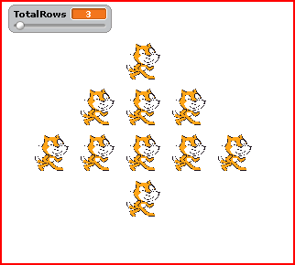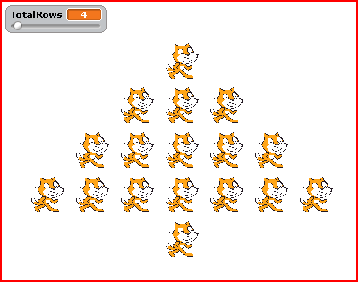

We’re going to create a slider for the number of rows the triangle part of the tree (not the trunk).

Part 1: Analysis

Size 3 Tree
Row |  | Spaces | Stamps
1 | * | 2 | 1
2 | *** | 1 | 3
3 | ***** | 0 | 5
Trunk | * | 2 | 1

Size 4 Tree
Row |  | Spaces | Stamps
1 | * | 3 | 1
2 | *** | 2 | 3
3 | ***** | 1 | 5
4 | ******* | 0 | 7
Trunk | * | 3 | 1

Now fill in the blanks for the Size 5 Tree below

Size 5 Tree
Row |  | Spaces | Stamps
1
2
3
4
5
Trunk

- Write an expression to determine the number of spaces on any row based on the current row number. Use row as the variable
- Are the number of stars on each row even or odd?

- How many stars are added to go from one row to the next?
- Write an expression to determine the number of stars on any row based on the current row number. Use row as the variable

- How many spaces are in the trunk row (before stamping the trunk). Hint: you can write an expression to calculate this using the variable TotalRows:

Open the file you last worked with (BoxCats.sb). Your code should look something like this:

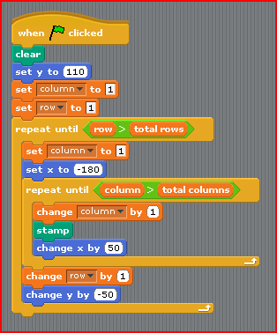
When the script starts
We clear the screen
We set the sprit at the top
We keep track of the row and column
For each row
We move the stamp to the left
We reset the column to 1
For each column
Add one to the column
Stamp
Move the stamp over
Once we’re done with a row – move down a row
We add one 1 the row

Click on the Save As button and save your file as treecats.sb.

Part 2: Coding

- To make our tree – will we still need our outer loop (repeat until row > TotalRows)?

- For each row we do two things – we print a bunch of spaces and then a bunch of stamps. Our inner loop currently only prints stamps. As it turns out, you can put two loops in a row in your code: one to do the spaces, then the other to do the stamps. Fill in the blanks here for the loop to do the spaces. Be sure to look at Part 1-A) from page 2 for what to fill in the blanks
repeat until column > __________ - ___________
change column by __________
change x by 50

- Add this loop to your code inside your outer loop just after you set your column to 1 (as shown here):
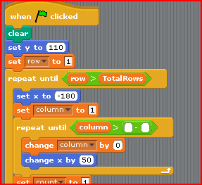
- What command is missing from the above loop that is in your original inner loop? If you’re unsure, try running the code right now and see what happens?
- Recall that the rest of our inner loop looked like what is shown below. Look back at the expression you came up with in Part 1-D) of your Analysis. How can you modify the repeat until statement so that it only repeats for the right number of stamps?
repeat until column > ______________________

- What happens if you run this right now? Does the tree print out correctly? What can you do to make it print out correctly? (Hint: you may have to re: initialize something)
- We’re missing one last thing on our tree, the trunk! In order to do this we have to add one more row. Does this row go inside or outside the outer loop?
- HOMEWORK: Write the code that will put the trunk on the tree

