- Vocabulary Review:

Initialization is setting up the initial or starting state of the script. A script might initialize a sprite’s location, whether the pen is up or down, whether the screen is cleared, or variables to an initial value.

The Flow of Control of a program is the order in which the statements are executed.

Single stepping is a mode in scratch that allows you to watch the script walk through the program block by block

Pseudocode is a script written in a more English like language. It’s helpful for programmers to talk about programs with each other or to think about and design their programs.

Debugging a program means finding and fixing problems in your script. The first bug found in a computer program was actually a moth found by Admiral Grace Hopper in 1947.

Hand execution is where you, the human, pretends to be computer and “executes” the program. It’s a sometimes tedious but very necessary skill for understanding and debugging programs.

A Variable is a placeholder for storing information that can change. A Global Variable can be accessed by any sprite. A Local Variable is one that can only be accessed by the sprite that it is local to.

A condition is something that is either true or false. In Scratch Conditions have angled edges, like this: . Expressions like x > -1 and x < 1 are conditions.

A Conditional control is a control where you stick a Condition into the block, and the controls inside the conditional control will only run if the condition was true. An if or an if else statement are examples of conditional controls, but so is repeat until. A Nested Conditional is, for instance, an if statement inside an if statement.

A Loop is a statement that executes all the statements inside it repeatedly. A Doubly Nested Loop is a loop statement inside a loop statement. A Triply Nested Loop is a loop inside a loop inside a loop. Sequential loops are one loop that follows another loop.

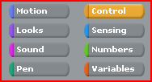
- Scavenger hunt:

For these questions the Blocks Palette will mean the area in the upper left hand corner of the Scratch screen.

- Loops are found under which area of the Blocks Palette?

- How many loop statements are there? List them:

- How many ways are there to change the value of a variable in a script (not in the stage)? Which area in the Blocks Palette do you find these statements?

- In which areas in the Blocks Palette do you find conditions?

- How many conditions are there in all of Scratch?

- Which conditions are “compound conditions” and where are they located?

- In which area in the Blocks Palette do you find the Conditional Controls?

- List all of the arithmetic operations you can perform in Scratch.

- Where is (0, 0) located on the Stage?

- List the ways can you change the x coordinate of the current sprite. (Hint: two of them are not as obvious as some of the others.)

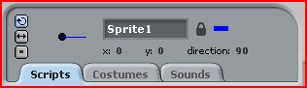
- Write the angles that are associated with the directions. Hint. Write a quick script that when the Green Flag is clicked, you point in direction ____. Change the value in the Point in direction statement, run the script and see what the information above the scripts pane says:

Left
Right
Up
Down

- List the ways you can change which direction the sprite is currently moving in. (Hint: again some of these are not as obvious as others).

- Hand Execution: Execute the following by hand and write down the results. This does not use the computer!

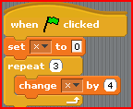
X =

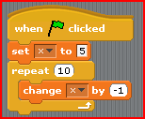
X =

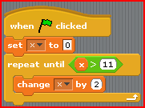
X =

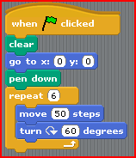
What does this draw?

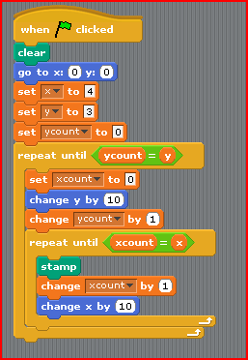
What does this draw? Assume the sprite looks like this: Be careful! this is NOT the same code as our “box cats” or “tree” code.

- Be creative!!!! Now it’s your turn to be creative. Write a new program that includes the following.

- At least one sprite (but it can have more than one)
- At least one variable
- At least one loop
- At least one condition and conditional statement or conditional loop

Think about some of the other things you’ve done with pens, stamps, races, etc.

But before you start playing with the code, write a bit of pseudocode or a design of what you’d like your program to do here!

