Scratch Independent Project Presentation

Hello, my name is _____________________________________________
The name of my project is ______________________________________
My project is a _______________________________________________
(game, slideshow, puzzle, maze, catlib, etc)

The part of my independent project that I like best is __________________ it has these unique features:_____________________________________
The variables I used are: (timer, score) ____________________________
The most interesting programming pieces I used are _________________
Additional information I would like to tell you about ___________________
This is how my (slideshow, game, puzzle….) works, This is how to start my project/game/puzzle. Let’s take a look at my project (Demonstrate Project)

The parts of my project that I would like to enhance or change in the future are_________________________________________________________
The thing I liked best about Scratch is _____________________________
Thank you for being a good audience.

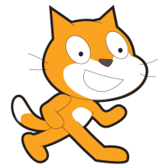
Relax and Enjoy Yourself.
You’ve worked hard and it shows.
Remember Scratch Cat Loves YOU!!!

