SCRATCH
- Download Scratch on your home computer, http://scratch.mit.edu/download

- Open up a Scratch Account to share your animations, http://scratch.mit.edu/. You will create a name and password.

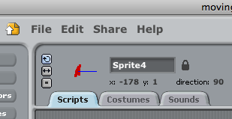
- Finished projects can be saved on the work computer or Shared on the Scratch website. Click on the Share button at the top of your open Scratch project.

  - You will need to use your account name and password to share on the Scratch website.

- Once you have saved animations to your Scratch page you can share them to the class gallery.

- You can put your animations and games on the class gallery page.

  - Art and Design, Group 1, share project to, http://scratch.mit.edu/galleries/view/140556
  - Art and Design, Group 2, share project to; http://scratch.mit.edu/galleries/view/140582
  - Art and Design, Group 3, share project to; http://scratch.mit.edu/galleries/view/140584

- Add me as a Friend, (under My stuff) so I can add you as a friend and we can all look at the projects the class creates and installs in the class gallery page.

Gretchen Romey-Tanzer
Upper School Art
Cape Cod Academy

