SCRATCH Project 2: Make the Cat Walk |  |  | SCRATCH Project 2: Make the Cat Walk
Page 1  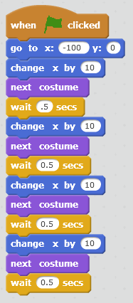 | Events  Motion  Change x to -100  Looks  Control  Change to .5  NOTE: If the cat is drawing lines, Go to "Pen"  click "pen up"  and "clear" |  | Page 1 | Events  Motion  Change x to -100  Looks  Control  Change to .5  NOTE: If the cat is drawing lines, Go to "Pen"  click "pen up"  and "clear"

"Scratch is developed by the Lifelong Kindergarten Group "Scratch is developed by the Lifelong Kindergarten Group
at the MIT Media Lab. See http://scratch.mit.edu". at the MIT Media Lab. See http://scratch.mit.edu".

SCRATCH Project 2: Make the Cat Walk More  Using the "repeat" block |  |  | SCRATCH Project 2: Make the Cat Walk More  Using the "repeat" block
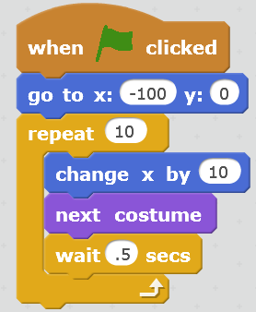 | Control |  |  | Control
NOW TRY THIS:  - Make the cat walk  - Faster  - Slower  - Farther  - Backward  - Up |  |  | NOW TRY THIS:  - Make the cat walk  - Faster  - Slower  - Farther  - Backward  - Up

