SCRATCH Project 3: More Drawing Squares  Page 1  Use the Repeat Block |  |  | SCRATCH Project 3: More Drawing Squares  Page 1  Use the Repeat Block
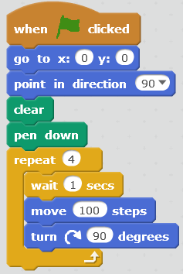 | Events  Motion  Pen  Control  Motion Change  10 to 100  Change  15 to 90 |  |  | Events  Motion  Pen  Control  Motion Change  10 to 100  Change  15 to 90

"Scratch is developed by the Lifelong Kindergarten Group "Scratch is developed by the Lifelong Kindergarten Group
at the MIT Media Lab. See http://scratch.mit.edu". at the MIT Media Lab. See http://scratch.mit.edu".

SCRATCH Project 3: More Drawing Squares  Page 2 Ask how long to make the side  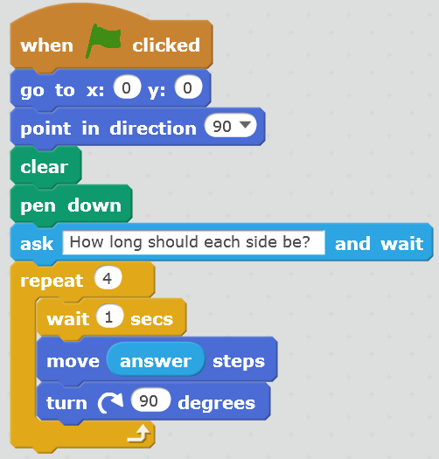  Sensing.  Drag answer here.  Sensing.  Type in "How long should each side be?"  WHAT could you do to fit a bigger square on the stage? |  | SCRATCH Project 3: More Drawing Squares  Page 2 Ask how long to make the side  Sensing.  Drag answer here.  Sensing.  Type in "How long should each side be?"  WHAT could you do to fit a bigger square on the stage?

