SCRATCH PROJECT 4: Draw a spiral Page 1
Step 1:First MAKE A VARIABLE. Call it "line length"
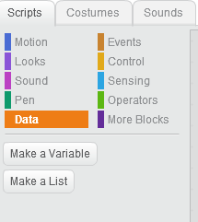  Click Here | 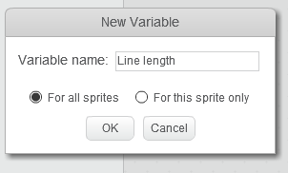  Type the variable name here | 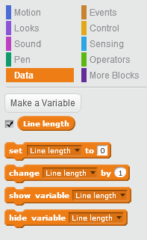  Drag this to where you need it
"Scratch is developed by the Lifelong Kindergarten Group at the MIT Media Lab.
See http://scratch.mit.edu".

SCRATCH PROJECT 4: Draw a spiral Page 1
Step 1:First MAKE A VARIABLE. Call it "line length"
Click Here | Type the variable name here | Drag this to where you need it
"Scratch is developed by the Lifelong Kindergarten Group at the MIT Media Lab.
See http://scratch.mit.edu".

Step 2: Put these blocks together  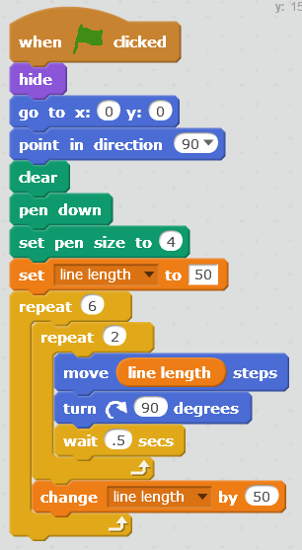  Data  Data  Control  Control  Data  Pen  Motion  Events  Looks |  | Step 2: Put these blocks together  Data  Data  Control  Control  Data  Pen  Motion  Events  Looks

