SCRATCH Project 5 Experiment with Circles Page 1
To draw a circle, you take 1 step, turn 1 degree and repeat 360 times.
1) Choose the "xy-grid" backdrop to help you compare your circles  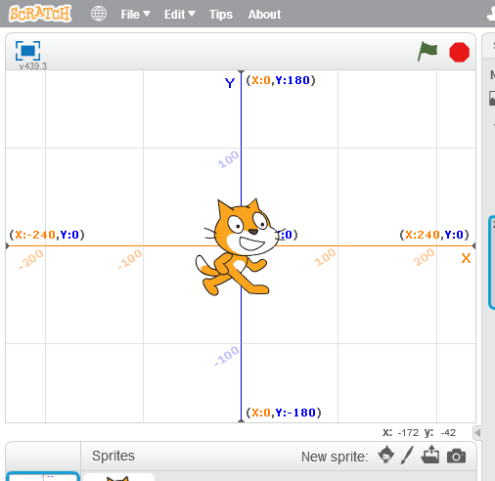 | 2) Set up a basic script to clear the stage and position the cat in the center  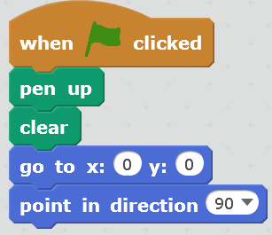 |  | 3) Now add the code to draw the circle:  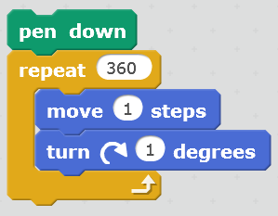
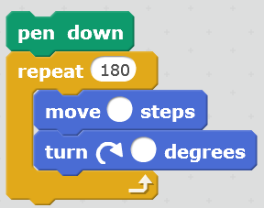  4) This takes a long time to draw. Try taking fewer steps and move & turn more on each step. Figure out which numbers go in the blanks.  What numbers go here? | 5) This is still pretty slow, try taking even fewer steps.  What numbers go here?  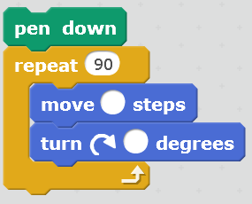 |  | 6) And even fewer…  What numbers go here?  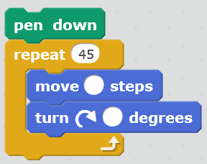
7) NOW use a repeat within a repeat to make this design with circles:  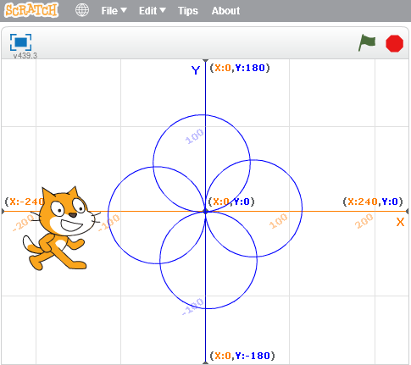 |  | Figure out what numbers to use.  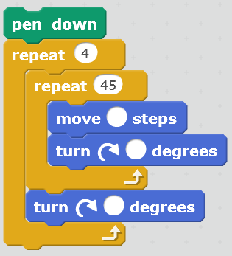

DRAW A CIRCLE AND DIVIDE IT INTO EQUAL SECTORS  Move out of the way  Sensing  Draw the lines  Events  Sensing  Draw the circle  Motion  Motion  Control  Motion  Pen | 1) What happens if they enter zero? Since you can't divide by zero, you need to send a message. Where should you put this?  Operator  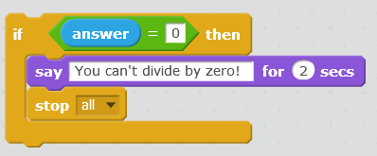  Looks  Control  Control  2) What happens if they enter 1? The circle is already one piece, so you need to send a message.  Change the code above and add it as well.  "Scratch is developed by the Lifelong Kindergarten Group at the MIT Media Lab.  See http://scratch.mit.edu".

