Delete the cat and add two sprites like you did in "Catch the Snowflake". The directions are based on the convertible and the snowflake, but you can use any two sprites. Just figure out how to size them properly.
1) Create a variable named "score" for all sprites

2) CAR: Click on the car and enter this code. You may need to experiment with the size.  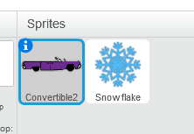 | 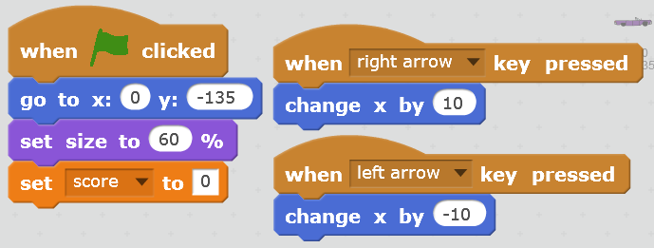

SCRATCH Project 7 PONG Page 1
Delete the cat and add two sprites like you did in "Catch the Snowflake". The directions are based on the convertible and the snowflake, but you can use any two sprites. Just figure out how to size them properly.
1) Create a variable named "score" for all sprites

2) CAR: Click on the car and enter this code. You may need to experiment with the size.

3) SNOWFLAKE: Click on the snowflake and enter this code. You may need to experiment with the size.  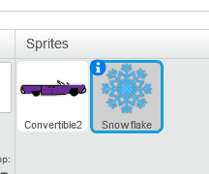 | 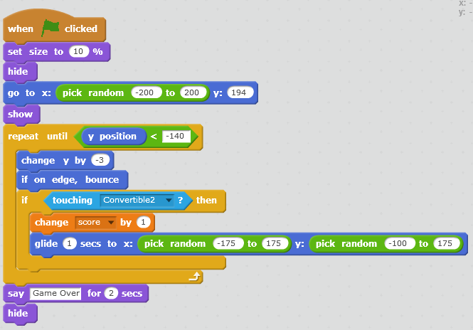
"Scratch is developed by the Lifelong Kindergarten Group at the MIT Media Lab.
See http://scratch.mit.edu".

SCRATCH Project 7 PONG Page 2
3) SNOWFLAKE: Click on the snowflake and enter this code. You may need to experiment with the size.

"Scratch is developed by the Lifelong Kindergarten Group at the MIT Media Lab.
See http://scratch.mit.edu".

