Name: Date:
Design & Technology 9 Section:

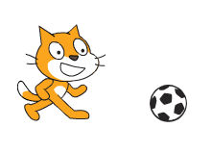
Scratch Do Now 10
Directions: This is a program for two sprites, Scratch Cat and the soccer ball. They begin in the positions shown at right. Take a look at the scripts for each sprite, and see if you can figure out what this program does.

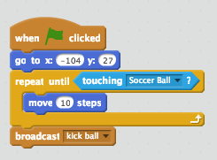
The script to the left belongs to Scratch Cat. Let’s take a look at it.

1. What event causes this script to run?

2. What does the first blue motion block do?

3. How does the loop in this script work? What actions does it cause to repeat, and when will it stop?

4. What happens after the loop finishes?

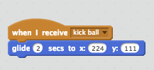
The script to the left belongs to the soccer ball sprite. Let’s take a look at it.

5. What event causes this script to run?

6. When this script runs, what does the soccer ball sprite do?

7. Think about both scripts together. What do you predict you will see on the screen if we run this program? Describe in detail!

8. What do you think the “broadcast” and “receive” blocks do? Use this program to help you figure it out.

