Name: Date:
Design & Technology 9 Section:

Scratch Do Now 11
Directions: Look at the scripts shown below. Think about what each script will do. Then write an explanation of how it works.

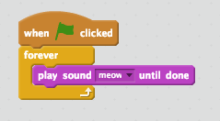
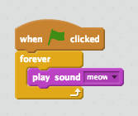
1. What is the difference between the two scripts at right?

2. If the goal is for the program to meow over and over again, which one is best to use? Why?
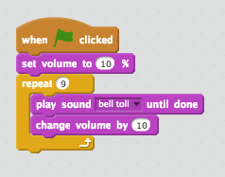
3. What do you expect to hear if the script to the right is played?
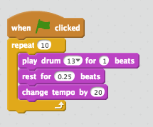
4. What do you expect to hear if the script to the right is played?

(Hint: Tempo is how fast music plays. It’s measured in bpm, or beats per minute.)

