Name: Date:
Design & Technology 9 Section:

Scratch Do Now 3
Directions: Look closely at the Scratch program shown below. Answer the questions to predict what it will do.

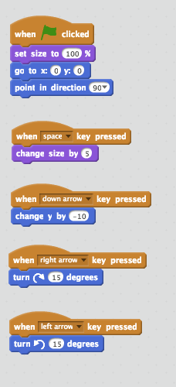
1. What happens to Scratch Cat when you press the spacebar?

2. What happens to Scratch Cat when you press the down arrow?

3. How can you make Scratch Cat turn to the right or to the left?

4. What does the first script at the top of the program do?

Why is this script important?

5. What blocks would you use to add a script that would make Scratch Cat move up the screen if you pressed the up arrow? Draw your script in the space below.

