Name: Date:
Design & Technology 9 Section:

Scratch Do Now 4
Directions: Match each combo block with what it will do. Then write a summary of what the program does.

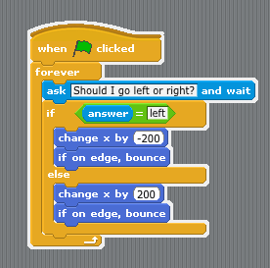

This is a program for the Mr. Meow sprite. What does this program do? Explain step by step.

When you press the green flag, the program

D
C
B
If you answer “left,” it

If you answer “right,” it

Then, it

