Name: Date:
Design & Technology 9 Section:

Scratch Do Now 7
Directions: Look at the program shown below. Think about what each combo block will do. Then write an explanation of how it works.

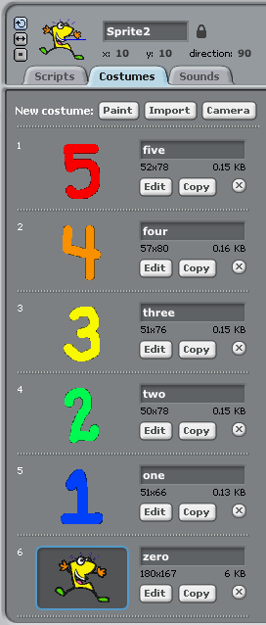
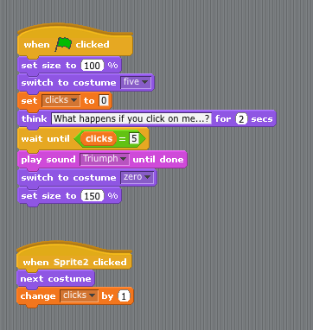

When you press the green flag, the program:
1.
2.
3.
4.

Each time you click on Sprite2, two things happen:
5.
6.

If you click on Sprite2 five times…
7.

