Name: Date:
Design & Technology 9 Section:

Scratch Do Now 8
Directions: Look at the program shown below. Think about what each combo block will do. Then write an explanation of how it works.

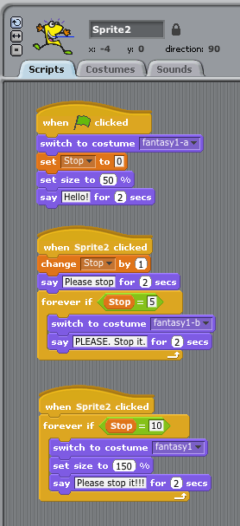
1. At the beginning of the program, the variable called is set to .
2. The program sets itself up when you press the green flag by , , and
3. What action will change the value of the variable by 1?
4. If you click on Sprite2 one time, what happens?
5. If you click on Sprite2 five times, what happens?
6. If you click on Sprite2 ten times, what happens?

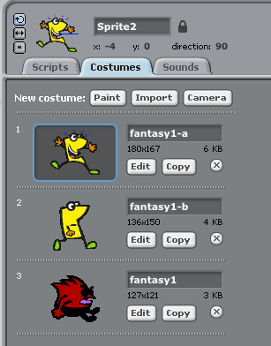
Note: This program was created by Trey & Dino,
in just 15 minutes of work time!

