Name: Date:
Design & Technology 9 Section:

Motion Exploration
Directions: Explore the blocks in the Motion menu (shown below). Use this page to take notes about what each one does. Try them out in small programs to see what they do!

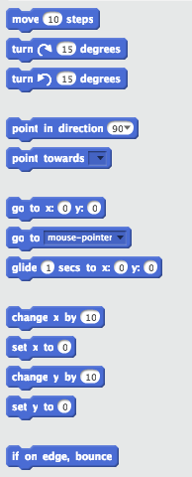
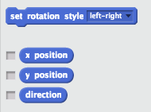
Name: Date:
Design & Technology 9 Section:

Looks Exploration
Directions: Explore the blocks in the Looks menu (shown below). Use this page to take notes about what each one does. Try them out in small programs to see what they do!
