Name: Date:
Design & Technology 9 Section:

Understanding Variables
Directions: Look at the program shown below. Think about what each combo block will do. Then write an explanation of how it works.

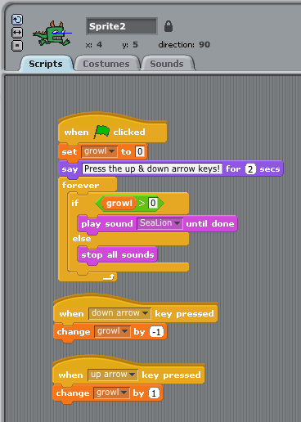
1. At the beginning of the program, the variable called is set to value =

2. One action that causes the value of the variable to change is
which makes the value of the variable

3. Another action that causes the value of the variable to change is
which makes the value of the variable

4. If the value of the variable is greater than 0, the sprite will
and if the value of the variable is less than or equal to, it will
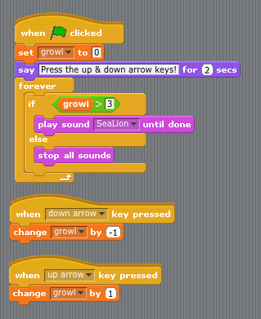
5. How would the change circled in white in the screenshot to the left change the way the program works?
Name: Date:
Design & Technology 9 Section:

Variables Challenge
Directions: Choose one of the project ideas below, or come up with your own. Create a working program that shows you know how to use a variable. Save it as Variables Demo Your Name(s) and email it to Ms. Vaughan. Complete the question at the bottom of the page for homework. You must import all sprites and backgrounds for this project – no drawing!

Project Choices:
- Create a countdown clock that measures 10 seconds and then causes something surprising to happen.
- Make a sprite that spins around every time you click it, but after 10 spins, gets dizzy and walks awkwardly off the stage.
- Create a sprite that chases another sprite, and bounces off the edge. If it hits the edge a certain number of times, it falls over.
- Create a program where a sprite moves faster and faster, but if it gets to a certain speed, it automatically slows down.
- Your own idea! (Keep it simple…)

Homework: Explain in detail how your variable works. What Scratch blocks did you use, and how do they work together?

